SECOND ASSIGNMENT REPORT
Lagrangian and Hamiltonian Mechanics



Name : Jeremia Christ Immanuel Manalu
NRP : 5023231017
Course : Biocybernetics
Class : Q
Lecturer : Dr. Achmad Arifin, S.T., M.Eng.
Department : Biomedical Engineering

FACULTY OF INTELLIGENT ELECTRICAL AND INFORMATICS TECHNOLOGY
INSTITUT TEKNOLOGI SEPULUH NOPEMBER
2026

CHAPTER I. FUNDAMENTAL THEORY

1.1 The Hodgkin-Huxley Membrane and Its Equivalent Circuit
Hodgkin and Huxley described the excitable membrane of the squid giant axon as an electrical circuit in which the lipid bilayer acts as a capacitor and every ionic pathway acts as a conductance in series with a battery that represents the Nernst potential of that ion [1]. The circuit used in this assignment follows the week-9 lecture material [2] and is shown in Figure 1.1. The capacitive current $J_{C}$ charges the membrane capacitance $C_{m}$, while the sodium, potassium and leakage currents $J_{Na}$, $J_{K}$ and $J_{L}$ flow through the conductances $g_{Na}$, $g_{K}$ and $g_{L}$. A stimulus current density $J_{in}$ is injected across the membrane. Because the patch is space clamped, the voltage is uniform over the membrane and Kirchhoff’s current law applied to the single node of the circuit gives the current balance of Equation (1.1), from which the voltage equation (1.2) follows directly.
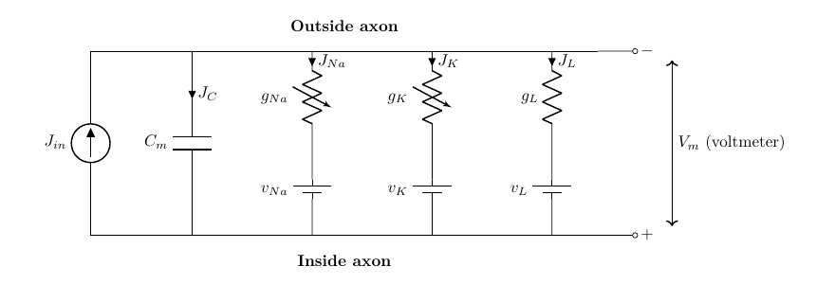
Figure 1.1. Equivalent circuit of a space-clamped membrane patch in the lecturer’s notation (rendered by the author after [1], [2])
$$J_{in}=C_{m}\frac{dv}{dt}+J_{Na}+J_{K}+J_{L} \left(1.1\right)$$
$$\frac{dv}{dt}=\frac{1}{C_{m}}\left[J_{in}-\left(J_{Na}+J_{K}+J_{L}\right)\right] \left(1.2\right)$$
The ionic currents obey Ohm’s law with a driving force equal to the difference between the membrane voltage and the reversal potential of each ion. Sodium and potassium conductances are not constant, Hodgkin and Huxley expressed them as a maximal conductance multiplied by powers of dimensionless gating variables $m$, $h$ and $n$, whereas the leakage conductance is constant [1]:
$$J_{Na}={\overset{‾}{g}}_{Na} m^{3}h \left(v-v_{Na}\right), J_{K}={\overset{‾}{g}}_{K} n^{4} \left(v-v_{K}\right), J_{L}={\overset{‾}{g}}_{L} \left(v-v_{L}\right) \left(1.3\right)$$
A point that must be handled carefully is the sign convention. The original paper and the lecture material [1], [2] define $v$ as the displacement of the membrane potential from rest with depolarization taken as negative, so that $v_{Na}=-115$ mV, $v_{K}=+12$ mV and $v_{L}=-10.613$ mV, and an inward (cathodal) stimulus is a negative $J_{in}$. Modern textbooks use the opposite sign and absolute potentials. The two descriptions are related by a reflection and a shift, and the program reports the physiological membrane voltage through the alignment of Equation (1.4) with a resting potential of $-70$ mV. With this alignment the resting state $v=0$ appears as $V_{m}=-70$ mV and an action potential appears as a positive excursion that peaks near $+35$ mV. The constants used throughout the work are those of the 1952 paper: ${\overset{‾}{g}}_{Na}=120$, ${\overset{‾}{g}}_{K}=36$ and ${\overset{‾}{g}}_{L}=0.3$ mS/cm², $C_{m}=1$ µF/cm², at the reference temperature of 6.3 °C.
$$V_{m}=-\left(v+70\right) \text{mV} \left(1.4\right)$$

1.2 Gating Kinetics and Rate Constants
Each gating variable represents the fraction of independent molecular gates that are in the permissive state and obeys first-order kinetics with voltage-dependent opening and closing rates $α_{x}\left(v\right)$ and $β_{x}\left(v\right)$ [1]. Equation (1.5) can be written equivalently as a relaxation toward the steady state $x_{∞}$ with the time constant $τ_{x}$ of Equation (1.6), which is the form used to interpret the phase plots in Chapter II.
$$\frac{dx}{dt}=α_{x}\left(1-x\right)-β_{x}x=-x\left(α_{x}+β_{x}\right)+α_{x}, x∈\{m,h,n\} \left(1.5\right)$$
$$x_{∞}=\frac{α_{x}}{α_{x}+β_{x}}, τ_{x}=\frac{1}{α_{x}+β_{x}} \left(1.6\right)$$
The empirical rate functions fitted by Hodgkin and Huxley to their voltage-clamp data are listed in Equation (1.7) to (1.9) in the lecturer’s sign convention, with $v$ in mV and the rates in ms⁻¹ [1], [2]. Two of them, $α_{m}$ and $α_{n}$, are of the form $a\left(v+b\right)/\left(e^{c\left(v+b\right)}-1\right)$ and become an indeterminate $0/0$ at $v=-25$ mV and $v=-10$ mV respectively. These are removable singularities whose limits follow from L’Hôpital’s rule, $α_{m}\left(-25\right)=1$ and $α_{n}\left(-10\right)=0.1$ ms⁻¹. The program evaluates both through the function $x/\left(e^{x}-1\right)$ of Equation (1.10), which is replaced by its second-order Taylor series when $\left|x\right|<{10}^{-4}$, instead of adding an arbitrary small number to the denominator.
$$α_{m}=\frac{0.1 \left(v+25\right)}{e^{0.1v+2.5}-1}, β_{m}=4 e^{v/18} \left(1.7\right)$$
$$α_{h}=0.07 e^{v/20}, β_{h}=\frac{1}{e^{0.1v+3}+1} \left(1.8\right)$$
$$α_{n}=\frac{0.01 \left(v+10\right)}{e^{0.1v+1}-1}, β_{n}=0.125 e^{v/80} \left(1.9\right)$$
$$\frac{x}{e^{x}-1}≈1-\frac{x}{2}+\frac{x^{2}}{12} \text{for }\left|x\right|<{10}^{-4} \left(1.10\right)$$
Temperature changes all rate constants by the same factor, written as $ϕ=3^{\left(T-6.3\right)/10}$ with $T$ in °C, which corresponds to a $Q_{10}$ of 3 [1]. Figure 1.2 shows the resulting steady states and time constants against the aligned membrane voltage. The sodium activation $m$ is fast (its time constant is below 0.5 ms everywhere), whereas the sodium inactivation $h$ and the potassium activation $n$ are slower by roughly an order of magnitude. This separation of time scales is the mechanism of the action potential: on depolarization $m$ follows the voltage almost instantly and opens the sodium conductance, which depolarizes the membrane further, while the delayed closure of $h$ and opening of $n$ terminate the spike and produce the after-hyperpolarization and the refractory period.
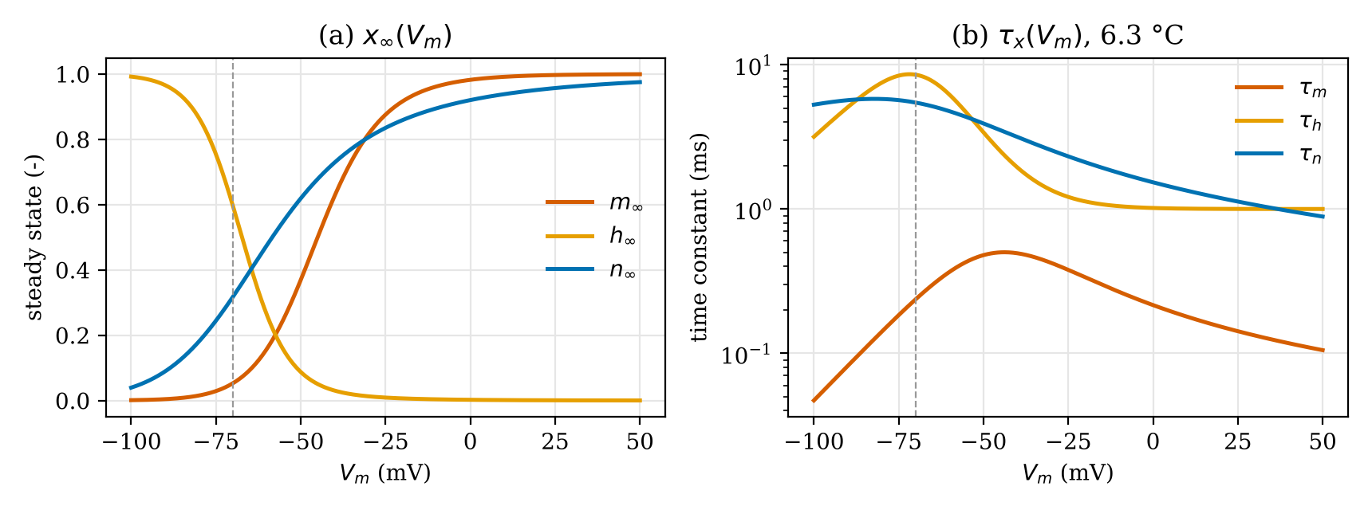
Figure 1.2. (a) Steady-state values and (b) time constants of the gating variables computed from Equation (1.6) to (1.9) at 6.3 °C, the dashed line marks the resting potential (plotted by the author from the rate functions of [1])

1.3 Fourth-Order Runge-Kutta Integration
The space-clamped model is a system of four coupled nonlinear ordinary differential equations for the state vector $Y={\left[v,m,h,n\right]}^{T}$, whose right-hand side $F\left(t,Y\right)$ is formed by Equation (1.2) and three copies of Equation (1.5). The lecture material [3] integrates it with the classical fourth-order Runge-Kutta (RK4) method [4], which evaluates four slope estimates per step and combines them with Simpson-like weights:
$$K_{1}=F\left(t_{k},Y_{k}\right), K_{2}=F\left(t_{k}+{Δt}/2, Y_{k}+{Δt}/2K_{1}\right) \left(1.11\right)$$
$$K_{3}=F\left(t_{k}+{Δt}/2, Y_{k}+{Δt}/2K_{2}\right), K_{4}=F\left(t_{k}+Δt, Y_{k}+Δt K_{3}\right) \left(1.12\right)$$
$$Y_{k+1}=Y_{k}+\frac{Δt}{6}\left(K_{1}+2K_{2}+2K_{3}+K_{4}\right) \left(1.13\right)$$
The local truncation error of RK4 is of order $Δt^{5}$ and the global error of order $Δt^{4}$ [4]. With the step of 0.01 ms used here (the slide prints “10 sec”, which can only be 10 µs because the lecturer’s code works in milliseconds), the scheme resolves the sodium upstroke, whose time scale is about 0.1 ms, with ample margin. The lecturer’s source code [3] applies RK4 in a slightly different way: the rate constants are frozen at $v_{k}$, each gate is advanced by its own scalar RK4 step, and the voltage is then advanced with the new gate values held constant. This is an operator-splitting scheme that is first order in the coupling between voltage and gates. Both variants are implemented in the program so that the results can be compared directly with the lecturer’s program.

1.4 The Cable Equation of Action Potential Propagation
To describe propagation, the axon is divided into segments of length $Δx$ that are connected by the internal (axoplasmic) and external resistances per unit length $r_{i}$ and $r_{o}$, as in the transmission-line model of the lecture [2] shown in Figure 1.3 [5]. Every membrane element is either a passive RC element ($c_{m}$, $g_{m}$) or, in the active cable, the complete Hodgkin-Huxley circuit of Figure 1.1.
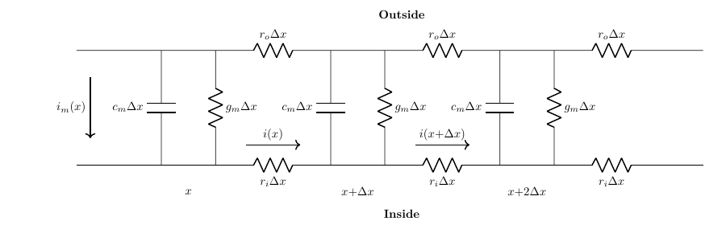
Figure 1.3. Discretized axon as an RC transmission line (rendered by the author after [2], [5])
Ohm’s law along the axis and Kirchhoff’s current law at a node give, in the limit $Δx→0$, the pair of equations (1.14) and (1.15), where $i$ is the axial current and $i_{m}$ the membrane current per unit length. Differentiating (1.14) with respect to $x$ and substituting (1.15) eliminates the axial current and yields the cable equation (1.16). Its derivation is repeated step by step as part of Problem 2 in Chapter II.
$$\frac{∂v}{∂x}=-\left(r_{o}+r_{i}\right)i \left(1.14\right)$$
$$\frac{∂i}{∂x}=-i_{m}=-\left(c_{m}\frac{∂v}{∂t}+i_{ion}\right) \left(1.15\right)$$
$$\frac{∂v}{∂t}=D \frac{∂^{2}v}{∂x^{2}}+\frac{J_{in}-J_{ion}}{C_{m}}, D=\frac{1}{\left(r_{o}+r_{i}\right)c_{m}} \left(1.16\right)$$
For a cylindrical axon of radius $a$ and axoplasm resistivity $R_{i}$, the per-length quantities are $r_{i}=R_{i}/\left(πa^{2}\right)$, $c_{m}=2πa C_{m}$ and $i_{ion}=2πa J_{ion}$, so that $i_{ion}/c_{m}=J_{ion}/C_{m}$ [5]. In the passive cable $J_{ion}=g_{m}v$ and a steady input decays along the axon with the length constant $λ={\left[2πa g_{m}\left(r_{o}+r_{i}\right)\right]}^{-1/2}$, such a cable cannot regenerate a signal. In the active cable $J_{ion}=J_{Na}+J_{K}+J_{L}$, so the depolarization that diffuses from an excited region into its neighbour opens the sodium conductance there and regenerates the full action potential. This is why an action potential travels at constant amplitude and constant velocity, and Hodgkin and Huxley showed that the velocity scales with $\sqrt{a}$ and computed 18.8 m/s for their squid axon at 18.5 °C, against 21.2 m/s measured [1]. The lecture slide writes the coefficient of the second derivative as ${\left[\left(r_{o}+r_{i}\right)C_{m}\right]}^{-1}$, where $C_{m}$ is the membrane capacitance per unit length (given there as $1.6×{10}^{-9}$ mF/mm), which is the same $D={\left[\left(r_{o}+r_{i}\right)c_{m}\right]}^{-1}$ as in Equation (1.16).

1.5 Finite Difference Approximation and Stability
The cable equation is a parabolic partial differential equation of the diffusion type, the same type as the heat equation $u_{t}=αu_{xx}$ used in the lecture to introduce its numerical solution [3]. On a grid $x_{j}=jh$, $t^{n}=nk$ with $v_{j}^{n}≈v\left(x_{j},t^{n}\right)$, the second spatial derivative is replaced by a central difference and the time derivative by a forward difference [4], [6]. The resulting explicit scheme, known as forward-time central-space (FTCS), computes every new value $v_{j}^{n+1}$ from three known values of the previous time level, as illustrated by the stencil in Figure 1.4.
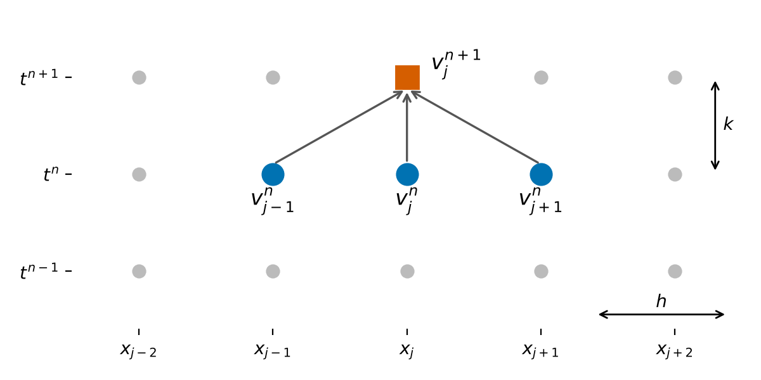
Figure 1.4. Stencil of the explicit forward-time central-space scheme: the new value (square) is computed from three values of the previous time level (circles)
The central difference has a truncation error of order $h^{2}$ and the forward difference of order $k$, so the scheme is consistent with an error of $O\left(k+h^{2}\right)$. Because it is explicit, it is only conditionally stable. A von Neumann analysis of the diffusion part shows that the amplification factor of a Fourier mode is $ξ=1-4r\sin^{2}\left(βh/2\right)$ with the diffusion number $r=Dk/h^{2}$, and $\left|ξ\right|≤1$ for every wave number only if $r≤1/2$ [6]. The full derivation of the scheme and of this condition is given as the answer of Problem 2. The program checks the condition before every run and refuses to integrate when it is violated, reporting the largest admissible time step $k_{max}=h^{2}/\left(2D\right)$.
The lecturer’s propagation code also contains a Crank-Nicolson variant, which averages the central difference over the old and the new time level. This trapezoidal rule is unconditionally stable and second-order accurate in time for the diffusion term, but it requires a tridiagonal system to be solved at every time step [6]. The program offers both schemes, and the Crank-Nicolson form is derived as an extension of Problem 2 in Section 2.2.3.

1.6 Refractory Period and Repetitive Firing
After an action potential the membrane cannot respond to a second stimulus for a short time and then responds only to a stronger one. During the absolute refractory period the sodium inactivation $h$ is still small and the potassium activation $n$ is still large, so no stimulus, however strong, can make the inward sodium current exceed the outward currents. During the relative refractory period $h$ recovers and $n$ decays with the time constants of Figure 1.2(b), and the threshold falls back toward its resting value [1]. Operationally, the refractory period is measured with a paired-pulse protocol: a conditioning pulse elicits an action potential and the smallest amplitude of a test pulse that still elicits a second action potential is determined as a function of the interval between the two pulses. A sustained depolarizing current, on the other hand, makes the membrane fire repetitively. After each spike the current recharges the membrane toward threshold, and the larger the current, the faster the threshold is reached once the refractoriness has decayed. The input level therefore programs the inter-pulse interval and hence the firing frequency, up to the point where the membrane remains depolarized, sodium inactivation stays high and firing stops (depolarization block). These two behaviours are the subject of Problem 1 and are quantified in Section 2.3.

CHAPTER II. RESULT AND ANALYSIS

2.1 Problems Statement
1. Prove of relationship of Hamilton’s principle and Lagrange Equation, with Lagrange function L=T-V, where T is Kinetic Energy, and V is Potential Energy.
a) $\frac{∂L}{∂\dot{θ̇}}=p$
b) A motion equation $ṗ=F$ can be derived form $\frac{d}{dt}\frac{∂L}{∂\dot{θ̇}}=\frac{∂L}{∂θ}$
2. For a position vector of a pendulum with a bob at the end of link in 3d coordinate as in this Figure.
- a) Determine expression of Kinetic and Potential Energy. You can use cylindrical polar coordinates 𝜌,𝜑,𝑧 or spherical polar coordinates 𝑟,𝜑,𝑧.
- b) Determine the motion equation based on Lagrangian method to get position and velocity of the motion, and based on Hamiltonian method to get position and momentum.

2.2 Answer and Code Explanation

2.2.1 Program Architecture
The program was developed in RAD Studio Delphi 13 Florence (VCL, Object Pascal) and is organized in three units. HHModel.pas is the numerical core and contains no user-interface code: it defines the model parameters and state records, the rate constants, both RK4 integrators, the stimulus protocols, the spike detector, the refractory and inter-pulse analyses and the cable solver. Unit1.pas with its form file Unit1.dfm is the main window, it reads the parameters from editable tables, calls the routines of HHModel.pas and draws the results with TeeChart. EquationViewer.pas opens every mathematical sheet (equivalent circuit, gating kinetics, RK4, cable equation, finite difference derivation and analysis definitions) in its own window with the caption “Jeremia Christ Immanuel Manalu - 5023231017 - ”, on these sheets, as in this report, the equations that are implemented in the code are highlighted in yellow. Keeping the numerics separate from the form made it possible to compile and regression-test HHModel.pas with Free Pascal against an independent Python implementation before it was used in the GUI.
The main window has six tabs: (1) APG with RK4, (2) gating phase plots, (3) refractory period, (4) C-F converter (Jin versus inter-pulse interval), (5) APP with the cable equation and (6) model parameters and equations. Every tab has a Clear button that removes its charts and results while keeping the parameters. Figure 2.1 shows the first tab and Figure 2.2 one of the derivation windows that are opened from the main form. The listings below follow the order of the problems in Section 2.1 and, within each problem, the order of the source files. Every line carries its line number in the source file. The numerical routines of HHModel.pas are complete, while in the routines of the form the lines that only read parameters, fill memos or repeat a statement for further series are replaced by one comment that names the omitted line range.
All visual elements of the main window are defined at design time in the form file Unit1.dfm, so they can be inspected in the Form Designer of Delphi before the program is compiled. The fourteen TeeChart charts are two-dimensional (View3D = False) and carry their titles, axis titles with units, grid, a legend with check boxes at the bottom and their 48 series (TFastLineSeries, TLineSeries and TPointSeries) in the Okabe-Ito and viridis colours of the program; the parameter tables (TValueListEditor) hold their keys and default values, and tab 6 holds the rendered equations. At run time the code only fills the series with the computed points (for example serVm.AddXY in PlotAPG), sets the titles that depend on a run (recording positions and instants in tab 5) and hides unused series; no series is created or freed while the program runs, which also removes the cause of the access violation recorded as ISS-020. The excerpt below shows the membrane-potential chart of tab 1 in Unit1.dfm (font, grid and position properties are omitted).
object chtVm: TChart
...
Legend.Alignment = laBottom
Legend.CheckBoxes = True
...
Legend.LegendStyle = lsSeries
...
Title.Text.Strings = (
'Membrane potential and stimulus')
...
BottomAxis.Title.Caption = 't (ms)'
...
LeftAxis.Title.Caption = 'Vm (mV)'
...
RightAxis.Title.Caption = 'Jin (uA/cm2)'
...
View3D = False
...
OnMouseMove = ChartMouseMove
...
OnZoom = ChartZoomed
object serVm: TFastLineSeries
SeriesColor = 0
Title = 'Vm'
...
LinePen.Width = 2
...
end
object serJin: TFastLineSeries
SeriesColor = 6316128
Title = 'Jin (right axis)'
...
LinePen.Width = 2
VertAxis = aRightAxis
...
end
end
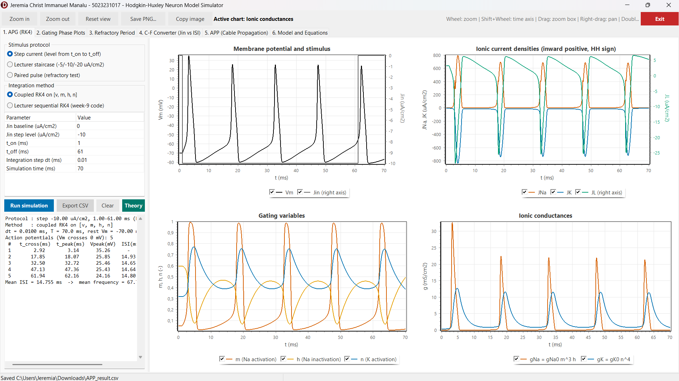
Figure 2.1. Main window of the simulator, tab “1. APG (RK4)”, after a step-current run
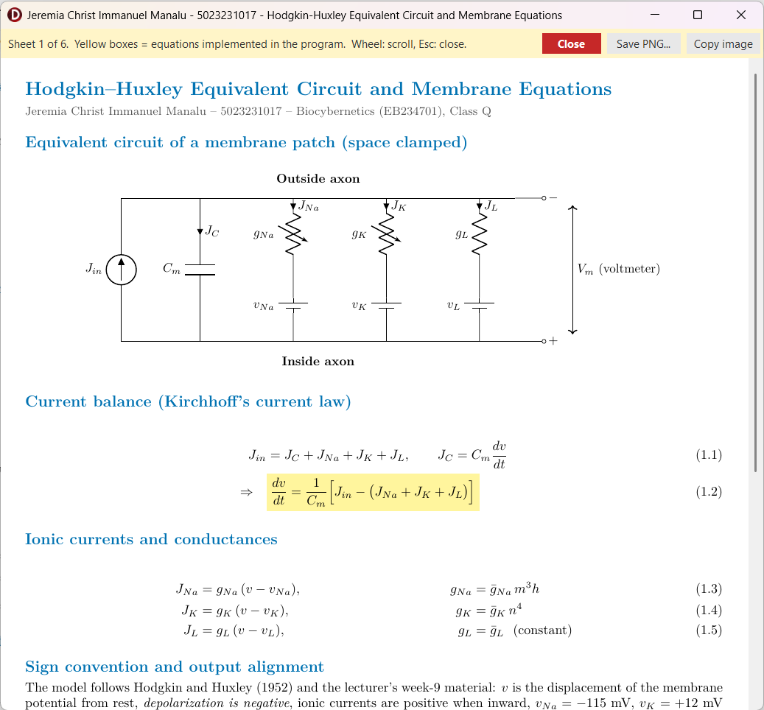
Figure 2.2. Sheet window opened from the main form (sheet 1, equivalent circuit and membrane equations), yellow boxes mark equations implemented in the program

2.2.2 Problem 1. Action Potential Generation with RK4
a. Model constants, rate constants and right-hand side
The routines below implement Equation (1.2) to (1.10). DefaultHHParams returns the constants of the 1952 paper in the lecturer’s sign convention. TemperatureFactor computes $ϕ=3^{\left(T-6.3\right)/10}$, which multiplies every rate constant. ExpRatio evaluates $x/\left(e^{x}-1\right)$ with the Taylor series near the removable singularity, and ComputeRates uses it to write $α_{m}$ and $α_{n}$ exactly: since $0.1\left(v+25\right)=0.1v+2.5$, the numerator of $α_{m}$ equals the exponent of its denominator, so $α_{m}=ExpRatio\left(0.1v+2.5\right)$, likewise $0.01\left(v+10\right)=0.1 \left(0.1v+1\right)$ gives $α_{n}=0.1 ExpRatio\left(0.1v+1\right)$. SteadyState returns $x_{∞}$ from Equation (1.6) and is used as the initial condition, so every run starts from the true resting state. IonicCurrents implements Equation (1.3), and RestingConductance returns the chord conductance ${\overset{‾}{g}}_{Na}m_{∞}^{3}h_{∞}+{\overset{‾}{g}}_{K}n_{∞}^{4}+{\overset{‾}{g}}_{L}$ of the resting membrane, 0.6773 mS/cm², which is used as $g_{m}$ of the passive cable in Problem 3 so that the passive and active cables have the same resting properties. Derivatives assembles $F\left(t,Y\right)$ from Equation (1.2) and (1.5).
223 function DefaultHHParams: THHParams;
224 begin
225 Result.GNa0 := 120.0;
226 Result.GK0 := 36.0;
227 Result.GL0 := 0.3;
228 Result.VNa := -115.0;
229 Result.VK := 12.0;
230 Result.VL := -10.613;
231 Result.Cm := 1.0; // 0.001 mF/cm2 = 1 uF/cm2 (lecturer slide)
232 Result.TempC := 6.3; // phi = 1, rate equations as published
233 end;
235 function TemperatureFactor(const P: THHParams): Double;
236 begin
237 // Q10 = 3 relative to the 6.3 deg C reference of Hodgkin & Huxley (1952)
238 Result := Power(3.0, (P.TempC - 6.3) / 10.0);
239 end;
241 function ExpRatio(const X: Double): Double;
242 begin
243 // X / (exp(X) - 1) with its removable singularity at X = 0 (limit = 1).
244 // A second-order Taylor expansion is used close to the singularity.
245 if Abs(X) < 1.0E-4 then
246 Result := 1.0 - 0.5 * X + X * X / 12.0
247 else
248 Result := X / (Exp(X) - 1.0);
249 end;
251 function ComputeRates(const V, Phi: Double): THHRates;
252 begin
253 // alpha_m = 0.1(v+25)/(exp(0.1v+2.5)-1) = ExpRatio(0.1v+2.5)
254 Result.Am := Phi * ExpRatio(0.1 * V + 2.5);
255 Result.Bm := Phi * 4.0 * Exp(V / 18.0);
256 Result.Ah := Phi * 0.07 * Exp(V / 20.0);
257 Result.Bh := Phi * 1.0 / (Exp(0.1 * V + 3.0) + 1.0);
258 // alpha_n = 0.01(v+10)/(exp(0.1v+1)-1) = 0.1 * ExpRatio(0.1v+1)
259 Result.An := Phi * 0.1 * ExpRatio(0.1 * V + 1.0);
260 Result.Bn := Phi * 0.125 * Exp(V / 80.0);
261 end;
263 function SteadyState(const V, Phi: Double): THHState;
264 var
265 Rt: THHRates;
266 begin
267 Rt := ComputeRates(V, Phi);
268 Result.V := V;
269 Result.M := Rt.Am / (Rt.Am + Rt.Bm);
270 Result.H := Rt.Ah / (Rt.Ah + Rt.Bh);
271 Result.N := Rt.An / (Rt.An + Rt.Bn);
272 end;
274 procedure IonicCurrents(const P: THHParams; const S: THHState;
275 out JNa, JK, JL: Double);
276 begin
277 JNa := P.GNa0 * S.M * S.M * S.M * S.H * (S.V - P.VNa);
278 JK := P.GK0 * S.N * S.N * S.N * S.N * (S.V - P.VK);
279 JL := P.GL0 * (S.V - P.VL);
280 end;
282 function RestingConductance(const P: THHParams): Double;
283 var
284 S: THHState;
285 begin
286 // Total (chord) membrane conductance of the resting membrane (mS/cm2);
287 // used as gm of the equivalent passive cable.
288 S := SteadyState(0.0, TemperatureFactor(P));
289 Result := P.GNa0 * S.M * S.M * S.M * S.H + P.GK0 * Sqr(Sqr(S.N)) + P.GL0;
290 end;
292 function Derivatives(const P: THHParams; const Phi: Double;
293 const S: THHState; const Jin: Double): THHState;
294 var
295 Rt: THHRates;
296 JNa, JK, JL: Double;
297 begin
298 Rt := ComputeRates(S.V, Phi);
299 IonicCurrents(P, S, JNa, JK, JL);
300 // Cm dv/dt = Jin - (JNa + JK + JL)
301 Result.V := (Jin - (JNa + JK + JL)) / P.Cm;
302 // dx/dt = alpha_x (1 - x) - beta_x x = -x(alpha_x + beta_x) + alpha_x
303 Result.M := Rt.Am * (1.0 - S.M) - Rt.Bm * S.M;
304 Result.H := Rt.Ah * (1.0 - S.H) - Rt.Bh * S.H;
305 Result.N := Rt.An * (1.0 - S.N) - Rt.Bn * S.N;
306 end;
b. Fourth-order Runge-Kutta integration
StepCoupledRK4 is a direct transcription of Equation (1.11) to (1.13) for the vector $Y={\left[v,m,h,n\right]}^{T}$, AddScaled forms the intermediate states $Y_{k}+c K$. The stimulus is evaluated at $t_{k}$, $t_{k}+Δt/2$ and $t_{k}+Δt$, which is required for fourth-order accuracy when $J_{in}$ changes in time. StepLecturerRK4 reproduces the week-9 code [3]: the rates are computed once at $v_{k}$, GateRK4 advances each gate with a scalar RK4 step of $dx/dt=α\left(1-x\right)-βx$, and the voltage is advanced by a scalar RK4 step in which the new gate values are held constant. Writing the gate step for frozen $α$ and $β$ makes clear why this is a splitting scheme: the exact solution of the frozen gate equation is $x_{k+1}=x_{∞}+\left(x_{k}-x_{∞}\right)e^{-Δt/τ_{x}}$, which RK4 reproduces to $O\left(Δt^{5}\right)$, but the voltage dependence of $α$ and $β$ within the step is neglected, which introduces a first-order coupling error. With $Δt=0.01$ ms the two methods differ by at most 0.01 ms in spike times in all tested cases.
308 function AddScaled(const A, B: THHState; const C: Double): THHState; inline;
309 begin
310 // A + C * B
311 Result.V := A.V + C * B.V;
312 Result.M := A.M + C * B.M;
313 Result.H := A.H + C * B.H;
314 Result.N := A.N + C * B.N;
315 end;
317 function StepCoupledRK4(const P: THHParams; const Phi: Double;
318 const S: THHState; const J0, JHalf, J1, Dt: Double): THHState;
319 var
320 K1, K2, K3, K4: THHState;
321 begin
322 // Classical 4th-order Runge-Kutta on Y = [v, m, h, n]:
323 // K1 = F(t, Y), K2 = F(t + dt/2, Y + dt/2 K1)
324 // K3 = F(t + dt/2, Y + dt/2 K2), K4 = F(t + dt, Y + dt K3)
325 // Y(t+dt) = Y + dt/6 (K1 + 2K2 + 2K3 + K4)
326 K1 := Derivatives(P, Phi, S, J0);
327 K2 := Derivatives(P, Phi, AddScaled(S, K1, 0.5 * Dt), JHalf);
328 K3 := Derivatives(P, Phi, AddScaled(S, K2, 0.5 * Dt), JHalf);
329 K4 := Derivatives(P, Phi, AddScaled(S, K3, Dt), J1);
330 Result.V := S.V + Dt / 6.0 * (K1.V + 2.0 * K2.V + 2.0 * K3.V + K4.V);
331 Result.M := S.M + Dt / 6.0 * (K1.M + 2.0 * K2.M + 2.0 * K3.M + K4.M);
332 Result.H := S.H + Dt / 6.0 * (K1.H + 2.0 * K2.H + 2.0 * K3.H + K4.H);
333 Result.N := S.N + Dt / 6.0 * (K1.N + 2.0 * K2.N + 2.0 * K3.N + K4.N);
334 end;
336 function GateRK4(const X, A, B, Dt: Double): Double;
337 var
338 K1, K2, K3, K4: Double;
339 begin
340 // Scalar RK4 of dx/dt = A(1-x) - Bx with A, B frozen during the step
341 K1 := Dt * (A * (1.0 - X) - B * X);
342 K2 := Dt * (A * (1.0 - (X + 0.5 * K1)) - B * (X + 0.5 * K1));
343 K3 := Dt * (A * (1.0 - (X + 0.5 * K2)) - B * (X + 0.5 * K2));
344 K4 := Dt * (A * (1.0 - (X + K3)) - B * (X + K3));
345 Result := X + (K1 + 2.0 * K2 + 2.0 * K3 + K4) / 6.0;
346 end;
348 function StepLecturerRK4(const P: THHParams; const Phi: Double;
349 const S: THHState; const Jin, Dt: Double): THHState;
350 var
351 Rt: THHRates;
352 Tmp: THHState;
353 K1, K2, K3, K4: Double;
354
355 function DV(const V: Double): Double;
356 var
357 JNa, JK, JL: Double;
358 begin
359 Tmp.V := V;
360 IonicCurrents(P, Tmp, JNa, JK, JL);
361 Result := (Jin - (JNa + JK + JL)) / P.Cm;
362 end;
363
364 begin
365 // Reproduces the week-9 source code: alpha/beta are evaluated once at
366 // v(t); n, m, h are advanced by independent scalar RK4 steps; then v is
367 // advanced by a scalar RK4 step with the NEW gate values held constant.
368 Rt := ComputeRates(S.V, Phi);
369 Result.N := GateRK4(S.N, Rt.An, Rt.Bn, Dt);
370 Result.M := GateRK4(S.M, Rt.Am, Rt.Bm, Dt);
371 Result.H := GateRK4(S.H, Rt.Ah, Rt.Bh, Dt);
372 Tmp := Result;
373 K1 := Dt * DV(S.V);
374 K2 := Dt * DV(S.V + 0.5 * K1);
375 K3 := Dt * DV(S.V + 0.5 * K2);
376 K4 := Dt * DV(S.V + K3);
377 Result.V := S.V + (K1 + 2.0 * K2 + 2.0 * K3 + K4) / 6.0;
378 end;
c. Alignment of the program output to the membrane voltage
The integrator works with the displacement $v$ of the lecturer’s convention, in which rest is $v=0$ and depolarization is negative. The physiological membrane voltage is obtained by reflecting the sign and adding the resting potential. If $V$ denotes the modern (depolarization-positive) displacement, the two conventions are related by $V=-v$, and the absolute membrane voltage is the resting potential plus this displacement:
$$V_{m}=V_{rest}+V=V_{rest}-v \left(2.1\right)$$
$$V_{m}=-70-v=-\left(v+70\right) \text{mV}, v=0⇒V_{m}=-70 \text{mV}, v=-105⇒V_{m}=+35 \text{mV} \left(2.2\right)$$
The same reflection explains the stimulus sign, a depolarizing (inward) current must make $v$ more negative, so it enters Equation (1.2) as a negative $J_{in}$. AbsoluteVm implements Equation (2.2), it is the only place where the alignment is made, and every chart, table and CSV export uses its result, while the reversal potentials remain in the lecturer’s convention ($v_{Na}=-115$ mV corresponds to $V_{m}=+45$ mV and $v_{K}=+12$ mV to $V_{m}=-82$ mV).
380 function AbsoluteVm(const V: Double): Double;
381 begin
382 // Alignment of the HH displacement v to the absolute membrane voltage
383 // Vm = -(v + 70) = V_REST_ABS - v
384 Result := V_REST_ABS - V;
385 end;

d. Stimulus protocols, APG run and spike detection
StimulusAt returns $J_{in}\left(t\right)$ for the three protocols of tab 1: a step from $t_{on}$ to $t_{off}$, the lecturer’s staircase ($-5$, $-10$ and $-20$ µA/cm² on $[0,25)$, $[25,38)$ and $[38,50)$ ms) and the paired pulse used for refractoriness. AdvanceState selects the integrator and CheckStepArguments rejects non-positive or excessive step counts. SimulateAPG starts from the resting steady state, stores $t$, $J_{in}$, $v$, $V_{m}$, the three ionic currents, the gates and the conductances $g_{Na}={\overset{‾}{g}}_{Na}m^{3}h$ and $g_{K}={\overset{‾}{g}}_{K}n^{4}$ at every step, and feeds $V_{m}$ to the spike detector. An action potential is defined by an upward crossing of $V_{m}=0$ mV, TSpikeDetector.Feed records the crossing time, follows the peak until the downward crossing and then stores the spike, and TSpikeDetector.Finish also counts a spike that is still above 0 mV when the run ends.
389 procedure AppendValue(var A: TDoubleArray; const Value: Double);
390 var
391 L: Integer;
392 begin
393 L := Length(A);
394 SetLength(A, L + 1);
395 A[L] := Value;
396 end;
398 procedure TSpikeDetector.Reset;
399 begin
400 Above := False;
401 PeakV := -1.0E30;
402 PeakT := 0.0;
403 CrossT := 0.0;
404 Count := 0;
405 SetLength(CrossTimes, 0);
406 SetLength(PeakTimes, 0);
407 SetLength(PeakValues, 0);
408 end;
410 procedure TSpikeDetector.Feed(const T, Vm: Double);
411 begin
412 if not Above then
413 begin
414 if Vm >= SPIKE_LEVEL then
415 begin
416 Above := True;
417 CrossT := T;
418 PeakV := Vm;
419 PeakT := T;
420 end;
421 end
422 else
423 begin
424 if Vm > PeakV then
425 begin
426 PeakV := Vm;
427 PeakT := T;
428 end;
429 if Vm < SPIKE_LEVEL then
430 begin
431 Above := False;
432 AppendValue(CrossTimes, CrossT);
433 AppendValue(PeakTimes, PeakT);
434 AppendValue(PeakValues, PeakV);
435 Inc(Count);
436 end;
437 end;
438 end;
440 procedure TSpikeDetector.Finish;
441 begin
442 // A spike still above the detection level when the run ends is counted
443 if Above then
444 begin
445 AppendValue(CrossTimes, CrossT);
446 AppendValue(PeakTimes, PeakT);
447 AppendValue(PeakValues, PeakV);
448 Inc(Count);
449 Above := False;
450 end;
451 end;
455 function DefaultStimulus: TStimulus;
456 begin
457 Result.Kind := skStep;
458 Result.JBase := 0.0;
459 Result.JLevel := -10.0;
460 Result.TOn := 1.0;
461 Result.TOff := 61.0;
462 Result.PulseWidth := 0.5;
463 Result.Interval := 15.0;
464 Result.JLevel2 := -40.0;
465 end;
467 function StimulusAt(const Stim: TStimulus; const T: Double): Double;
468 begin
469 case Stim.Kind of
470 skStep:
471 if (T >= Stim.TOn) and (T < Stim.TOff) then
472 Result := Stim.JLevel
473 else
474 Result := Stim.JBase;
475 skLecturerStaircase:
476 // identical to the lecturer's week-9 source code
477 if (T >= 0.0) and (T < 25.0) then
478 Result := -5.0
479 else if (T >= 25.0) and (T < 38.0) then
480 Result := -10.0
481 else if (T >= 38.0) and (T < 50.0) then
482 Result := -20.0
483 else
484 Result := 0.0;
485 skPairedPulse:
486 if (T >= Stim.TOn) and (T < Stim.TOn + Stim.PulseWidth) then
487 Result := Stim.JLevel
488 else if (T >= Stim.TOn + Stim.Interval) and
489 (T < Stim.TOn + Stim.Interval + Stim.PulseWidth) then
490 Result := Stim.JLevel2
491 else
492 Result := Stim.JBase;
493 else
494 Result := 0.0;
495 end;
496 end;
500 function AdvanceState(const P: THHParams; const Phi: Double;
501 const Stim: TStimulus; const S: THHState; const T, Dt: Double;
502 const Method: TIntegrator): THHState;
503 begin
504 if Method = imCoupledRK4 then
505 Result := StepCoupledRK4(P, Phi, S, StimulusAt(Stim, T),
506 StimulusAt(Stim, T + 0.5 * Dt), StimulusAt(Stim, T + Dt), Dt)
507 else
508 Result := StepLecturerRK4(P, Phi, S, StimulusAt(Stim, T), Dt);
509 end;
511 procedure CheckStepArguments(const Dt, TEnd: Double);
512 begin
513 if (Dt <= 0.0) or IsNan(Dt) then
514 raise EArgumentException.Create('Integration step dt must be positive.');
515 if (TEnd <= 0.0) or IsNan(TEnd) then
516 raise EArgumentException.Create('Simulation time must be positive.');
517 if TEnd / Dt > 5.0E6 then
518 raise EArgumentException.Create(
519 'Too many integration steps (TEnd/dt > 5e6). Increase dt or reduce TEnd.');
520 end;
522 procedure SimulateAPG(const P: THHParams; const Stim: TStimulus;
523 const Dt, TEnd: Double; const Method: TIntegrator; out R: TAPGResult);
524 var
525 Phi, T: Double;
526 S: THHState;
527 I, NSteps: Integer;
528 JNa, JK, JL: Double;
529 Det: TSpikeDetector;
530
531 procedure Store(const Idx: Integer; const Time, Jin: Double);
532 begin
533 IonicCurrents(P, S, JNa, JK, JL);
534 R.T[Idx] := Time;
535 R.V[Idx] := S.V;
536 R.Vm[Idx] := AbsoluteVm(S.V);
537 R.Jin[Idx] := Jin;
538 R.JNa[Idx] := JNa;
539 R.JK[Idx] := JK;
540 R.JL[Idx] := JL;
541 R.M[Idx] := S.M;
542 R.H[Idx] := S.H;
543 R.N[Idx] := S.N;
544 R.GNa[Idx] := P.GNa0 * S.M * S.M * S.M * S.H;
545 R.GK[Idx] := P.GK0 * Sqr(Sqr(S.N));
546 end;
547
548 begin
549 CheckStepArguments(Dt, TEnd);
550 Phi := TemperatureFactor(P);
551 NSteps := Round(TEnd / Dt);
552 R.Count := NSteps + 1;
553 SetLength(R.T, R.Count);
554 SetLength(R.Vm, R.Count);
555 SetLength(R.V, R.Count);
556 SetLength(R.Jin, R.Count);
557 SetLength(R.JNa, R.Count);
558 SetLength(R.JK, R.Count);
559 SetLength(R.JL, R.Count);
560 SetLength(R.M, R.Count);
561 SetLength(R.H, R.Count);
562 SetLength(R.N, R.Count);
563 SetLength(R.GNa, R.Count);
564 SetLength(R.GK, R.Count);
565
566 // Initial condition: membrane at rest, gates at their steady state
567 S := SteadyState(0.0, Phi);
568 Det.Reset;
569 Store(0, 0.0, StimulusAt(Stim, 0.0));
570 Det.Feed(0.0, R.Vm[0]);
571 for I := 1 to NSteps do
572 begin
573 T := (I - 1) * Dt;
574 S := AdvanceState(P, Phi, Stim, S, T, Dt, Method);
575 Store(I, I * Dt, StimulusAt(Stim, I * Dt));
576 Det.Feed(I * Dt, R.Vm[I]);
577 end;
578 Det.Finish;
579 R.SpikeCross := Copy(Det.CrossTimes);
580 R.SpikeTimes := Copy(Det.PeakTimes);
581 R.SpikePeaks := Copy(Det.PeakValues);
582 end;
584 procedure SimulateSpikesOnly(const P: THHParams; const Stim: TStimulus;
585 const Dt, TEnd: Double; const Method: TIntegrator;
586 var Det: TSpikeDetector);
587 var
588 Phi: Double;
589 S: THHState;
590 I, NSteps: Integer;
591 begin
592 CheckStepArguments(Dt, TEnd);
593 Phi := TemperatureFactor(P);
594 NSteps := Round(TEnd / Dt);
595 S := SteadyState(0.0, Phi);
596 Det.Reset;
597 Det.Feed(0.0, AbsoluteVm(S.V));
598 for I := 1 to NSteps do
599 begin
600 S := AdvanceState(P, Phi, Stim, S, (I - 1) * Dt, Dt, Method);
601 Det.Feed(I * Dt, AbsoluteVm(S.V));
602 end;
603 Det.Finish;
604 end;
On the form, btnRunAPGClick reads the protocol and the parameters, validates them, runs SimulateAPG and calls the plotting and report routines. PlotAPG draws $V_{m}$ with $J_{in}$ on a right axis, the three ionic currents ($J_{L}$ on its own right axis because it is two orders of magnitude smaller than $J_{Na}$ and $J_{K}$), the gates and the conductances, the four time axes are synchronized when zooming. PlotPhase draws the trajectories of $m$, $h$ and $n$ against $V_{m}$ as dots at a constant time stride over the steady-state curves $x_{∞}\left(V_{m}\right)$, together with $τ_{x}\left(V_{m}\right)$ on a logarithmic axis, which makes the lag of each gate behind its steady state visible. ReportAPG lists the spike times, peaks and inter-spike intervals in the result memo.
1390 procedure TForm1.BuildAPGStimulus(out AStim: TStimulus);
1391 begin
1392 // stimulus of tab 1; also used as the source of the APG waveform that
1393 // drives the cable at x = 0 in tab 5
1394 AStim := DefaultStimulus;
1395 case rgProtocol.ItemIndex of
1396 1:
1397 AStim.Kind := skLecturerStaircase;
1398 2:
1399 begin
1400 AStim.Kind := skPairedPulse;
{ lines 1401-1406 omitted: J base, t_on, J1, J2, width, interval }
1407 if AStim.PulseWidth <= 0.0 then
1408 raise EConvertError.Create('Pulse width must be positive.');
1409 if AStim.Interval < AStim.PulseWidth then
1410 raise EConvertError.Create(
1411 'Pulse interval must not be shorter than the pulse width.');
1412 end;
1413 else
1414 AStim.Kind := skStep;
1415 AStim.JBase := ParamValue(vleAPG, K_JBASE);
1416 AStim.JLevel := ParamValue(vleAPG, K_JLEVEL);
1417 AStim.TOn := ParamValue(vleAPG, K_TON);
1418 AStim.TOff := ParamValue(vleAPG, K_TOFF);
1419 if AStim.TOff <= AStim.TOn then
1420 raise EConvertError.Create('t_off must be larger than t_on.');
1421 end;
1422 end;
1424 procedure TForm1.btnRunAPGClick(Sender: TObject);
1425 var
1426 LParams: THHParams;
1427 LStim: TStimulus;
1428 LDt, LTEnd: Double;
1429 begin
1430 try
1431 LParams := ReadModelParams;
1432 BuildAPGStimulus(LStim);
1433 LDt := ParamValue(vleAPG, K_DT);
1434 LTEnd := ParamValue(vleAPG, K_TEND);
1435
1436 Screen.Cursor := crHourGlass;
1437 try
1438 SimulateAPG(LParams, LStim, LDt, LTEnd, SelectedMethod, FAPG);
1439 finally
1440 Screen.Cursor := crDefault;
1441 end;
1442 FAPGValid := True;
1443 PlotAPG;
1444 PlotPhase(LParams);
1445 ReportAPG(LStim, LDt, LTEnd);
1446 SetStatus(Format('APG finished: %d samples, %d action potentials.',
1447 [FAPG.Count, Length(FAPG.SpikeTimes)]));
1448 except
1449 on E: Exception do
1450 ShowError(E.Message);
1451 end;
1452 end;
1454 procedure TForm1.PlotAPG;
1455 var
1456 LIdx, LStride: Integer;
1457 begin
1458 // series of the four APG charts are designed in Unit1.dfm; JL (about
1459 // +/-25 uA/cm2) is on the right axis because it would be invisible next
1460 // to JNa and JK (about +/-800 uA/cm2), Jin is on the right axis of chtVm
1461 ClearChart(chtVm);
1462 ClearChart(chtCurrents);
1463 ClearChart(chtGates);
1464 ClearChart(chtConductance);
1465 // at most about 8000 points per series keeps TeeChart responsive
1466 LStride := Max(1, FAPG.Count div 8000);
1467 LIdx := 0;
1468 while LIdx < FAPG.Count do
1469 begin
1470 serVm.AddXY(FAPG.T[LIdx], FAPG.Vm[LIdx]);
{ lines 1471-1479 omitted: the other nine series in the same way }
1480 Inc(LIdx, LStride);
1481 end;
1482 FinishChart(chtVm);
{ lines 1483-1485 omitted: FinishChart of the other charts }
1486 end;
1488 procedure TForm1.PlotPhase(const AParams: THHParams);
1489 const
1490 C_VM_FROM = -100.0; // range of the steady-state curves (mV)
1491 C_VM_TO = 50.0;
1492 C_VM_STEP = 0.5;
1493 var
1494 LIdx, LStride, LCount: Integer;
1495 LPhi, LVm, LV: Double;
1496 LRates: THHRates;
1497 begin
{ lines 1498-1506 omitted: comment, ClearChart of the four charts }
1507
1508 LStride := Max(1, FAPG.Count div 4000);
1509 LIdx := 0;
1510 while LIdx < FAPG.Count do
1511 begin
1512 serTrajM.AddXY(FAPG.Vm[LIdx], FAPG.M[LIdx]);
1513 serTrajH.AddXY(FAPG.Vm[LIdx], FAPG.H[LIdx]);
1514 serTrajN.AddXY(FAPG.Vm[LIdx], FAPG.N[LIdx]);
1515 Inc(LIdx, LStride);
1516 end;
1517
1518 LPhi := TemperatureFactor(AParams);
1519 LCount := Round((C_VM_TO - C_VM_FROM) / C_VM_STEP);
1520 for LIdx := 0 to LCount do
1521 begin
1522 LVm := C_VM_FROM + LIdx * C_VM_STEP;
1523 LV := V_REST_ABS - LVm; // HH displacement: v = -(Vm + 70)
1524 LRates := ComputeRates(LV, LPhi);
1525 serInfM.AddXY(LVm, LRates.Am / (LRates.Am + LRates.Bm));
{ lines 1526-1530 omitted: h_inf, n_inf, tau_m, tau_h, tau_n alike }
1531 end;
{ lines 1532-1535 omitted: FinishChart of the four charts }
1536 end;
1538 procedure TForm1.ReportAPG(const AStim: TStimulus; const ADt, ATEnd: Double);
1539 var
1540 LLines: TStrings;
1541 LIdx, LCount: Integer;
1542 LSpan: Double;
1543 begin
{ lines 1544-1584 omitted: memo header and spike table }
1585 if LCount > 1 then
1586 begin
1587 LSpan := FAPG.SpikeTimes[LCount - 1] - FAPG.SpikeTimes[0];
1588 LLines.Add(Format('Mean ISI = %s ms -> mean frequency = %s Hz',
1589 [FloatText(LSpan / (LCount - 1), 3),
1590 FloatText(1000.0 * (LCount - 1) / LSpan, 2)]));
1591 end;
1592 end;
{ lines 1593-1604 omitted: paired-pulse note, EndUpdate }
1605 end;
e. Refractory period
The refractory period is measured with the paired-pulse protocol of Section 1.6. PairedStimulus builds a conditioning pulse $J_{1}$ of width $w$ at $t_{on}=1$ ms and a test pulse $J_{2}$ at $t_{on}+ΔT$. SecondSpikeOccurs integrates the model and reports whether a spike crosses 0 mV after the onset of the test pulse. SinglePulseThreshold determines the rested threshold $J_{th,0}$ and SecondPulseThreshold the test threshold $J_{th}\left(ΔT\right)$ by bisection on $\left[0,{\left|J_{2}\right|}_{max}\right]$. Bisection is valid because the response is monotone in the amplitude: if an amplitude elicits a spike, every larger one does as well. After 16 halvings the threshold is bracketed to ${\left|J_{2}\right|}_{max}/2^{16}$, about 0.008 µA/cm² for ${\left|J_{2}\right|}_{max}=500$ µA/cm². The definitions used for the two phases of refractoriness are:
$$J_{th}\left(ΔT\right)=min\left\{\left|J_{2}\right|: \text{a second AP occurs}\right\}, \text{absolute: }J_{th}\left(ΔT\right)>{\left|J_{2}\right|}_{max}, \text{relative: }J_{th,0}<J_{th}\left(ΔT\right) \left(2.3\right)$$
and the relative refractory period is taken to end when $J_{th}\left(ΔT\right)≤1.05 J_{th,0}$. On the form, btnRunRefClick sweeps the interval, plots $J_{th}\left(ΔT\right)$ with the rested threshold as a reference and the peak of the second action potential on a right axis, and derives both phase durations; RunRefExample simulates the paired-pulse response for the interval selected with the track bar.
613 function PairedStimulus(const J1, J2, Width, Interval: Double): TStimulus;
614 begin
615 Result := DefaultStimulus;
616 Result.Kind := skPairedPulse;
617 Result.JBase := 0.0;
618 Result.JLevel := J1;
619 Result.JLevel2 := J2;
620 Result.TOn := PAIRED_T_ON;
621 Result.PulseWidth := Width;
622 Result.Interval := Interval;
623 end;
625 function SecondSpikeOccurs(const P: THHParams; const J1, J2, Width,
626 Interval, Dt: Double; const Method: TIntegrator;
627 out SecondPeak: Double): Boolean;
628 var
629 Det: TSpikeDetector;
630 TTest: Double;
631 I: Integer;
632 begin
633 // The test response is a spike whose upward 0 mV crossing occurs after
634 // the onset of the second (test) pulse.
635 TTest := PAIRED_T_ON + Interval;
636 SimulateSpikesOnly(P, PairedStimulus(J1, J2, Width, Interval), Dt,
637 TTest + PAIRED_T_AFTER, Method, Det);
638 Result := False;
639 SecondPeak := NaN;
640 I := 0;
641 while (not Result) and (I < Det.Count) do
642 begin
643 if Det.CrossTimes[I] >= TTest then
644 begin
645 Result := True;
646 SecondPeak := Det.PeakValues[I];
647 end;
648 Inc(I);
649 end;
650 end;
652 function SinglePulseThreshold(const P: THHParams; const Sign, Width,
653 JMaxAbs, Dt: Double; const Method: TIntegrator): Double;
654 var
655 Lo, Hi, Mid: Double;
656 K: Integer;
657 Det: TSpikeDetector;
658 Stim: TStimulus;
659
660 function Fires(const A: Double): Boolean;
661 begin
662 Stim := PairedStimulus(Sign * A, 0.0, Width, 1.0E6);
663 SimulateSpikesOnly(P, Stim, Dt, PAIRED_T_ON + PAIRED_T_AFTER, Method, Det);
664 Result := Det.Count > 0;
665 end;
666
667 begin
668 // Smallest |J| of a single pulse that elicits an action potential
669 if not Fires(JMaxAbs) then
670 Exit(NaN);
671 Lo := 0.0;
672 Hi := JMaxAbs;
673 for K := 1 to BISECTION_STEPS do
674 begin
675 Mid := 0.5 * (Lo + Hi);
676 if Fires(Mid) then
677 Hi := Mid
678 else
679 Lo := Mid;
680 end;
681 Result := Hi;
682 end;
684 function SecondPulseThreshold(const P: THHParams; const J1, Width,
685 Interval, JMaxAbs, Dt: Double; const Method: TIntegrator): Double;
686 var
687 Lo, Hi, Mid, Pk, Sign: Double;
688 K: Integer;
689 begin
690 // Minimum |J2| of the test pulse that produces a second action potential.
691 // NaN means no response up to JMaxAbs: absolute refractory period.
692 if J1 < 0.0 then
693 Sign := -1.0
694 else
695 Sign := 1.0;
696 if not SecondSpikeOccurs(P, J1, Sign * JMaxAbs, Width, Interval, Dt,
697 Method, Pk) then
698 Exit(NaN);
699 Lo := 0.0;
700 Hi := JMaxAbs;
701 for K := 1 to BISECTION_STEPS do
702 begin
703 Mid := 0.5 * (Lo + Hi);
704 if SecondSpikeOccurs(P, J1, Sign * Mid, Width, Interval, Dt, Method, Pk) then
705 Hi := Mid
706 else
707 Lo := Mid;
708 end;
709 Result := Hi;
710 end;
1657 procedure TForm1.btnRunRefClick(Sender: TObject);
1658 var
1659 LParams: THHParams;
1660 LJ1, LWidth, LI0, LI1, LStep, LJMax, LDt, LPeak, LSign: Double;
1661 LCount, LIdx, LAbsIdx, LRelIdx: Integer;
1662 LLines: TStrings;
1663 begin
1664 if FBusy then
1665 Exit;
1666 FBusy := True;
1667 try
1668 LParams := ReadModelParams;
{ lines 1669-1675 omitted: read parameters from vleRef }
1676 if (LWidth <= 0.0) or (LStep <= 0.0) or (LI1 < LI0) or (LI0 < LWidth) then
1677 raise EConvertError.Create('Require width > 0, step > 0, ' +
1678 'interval start >= width and interval end >= interval start.');
1679 if LJ1 < 0.0 then
1680 LSign := -1.0
1681 else
1682 LSign := 1.0;
1683 LCount := Floor((LI1 - LI0) / LStep + 1.0E-9) + 1;
1684 SetLength(FRefInterval, LCount);
1685 SetLength(FRefThreshold, LCount);
1686 SetLength(FRefPeak, LCount);
1687
1688 Screen.Cursor := crHourGlass;
1689 try
1690 FRefBaseline := SinglePulseThreshold(LParams, LSign, LWidth, LJMax, LDt,
1691 SelectedMethod);
1692 for LIdx := 0 to LCount - 1 do
1693 begin
1694 FRefInterval[LIdx] := LI0 + LIdx * LStep;
1695 FRefThreshold[LIdx] := SecondPulseThreshold(LParams, LJ1, LWidth,
1696 FRefInterval[LIdx], LJMax, LDt, SelectedMethod);
1697 if SecondSpikeOccurs(LParams, LJ1, LJ1, LWidth, FRefInterval[LIdx],
1698 LDt, SelectedMethod, LPeak) then
1699 FRefPeak[LIdx] := LPeak
1700 else
1701 FRefPeak[LIdx] := NaN;
1702 SetStatus(Format('Refractory sweep %d / %d', [LIdx + 1, LCount]));
1703 Application.ProcessMessages;
1704 end;
1705 finally
1706 Screen.Cursor := crDefault;
1707 end;
1708
{ lines 1709-1726 omitted: plot serRefThr, serRefBase, serRefPeak }
1727
1728 // absolute refractory: no response up to JMax;
1729 // relative refractory ends when threshold <= 105 % of the rested value
1730 LAbsIdx := -1;
1731 for LIdx := 0 to LCount - 1 do
1732 if IsNan(FRefThreshold[LIdx]) then
1733 LAbsIdx := LIdx;
1734 LRelIdx := -1;
1735 LIdx := LAbsIdx + 1;
1736 while (LRelIdx < 0) and (LIdx < LCount) do
1737 begin
1738 if (not IsNan(FRefThreshold[LIdx])) and (not IsNan(FRefBaseline)) and
1739 (FRefThreshold[LIdx] <= 1.05 * FRefBaseline) then
1740 LRelIdx := LIdx;
1741 Inc(LIdx);
1742 end;
1743
{ lines 1744-1777 omitted: memo: refractory phases and table }
1778 SetStatus('Refractory sweep finished. Move the track bar to inspect ' +
1779 'single intervals.');
1780 except
1781 on E: Exception do
1782 ShowError(E.Message);
1783 end;
1784 FBusy := False;
1785 RunRefExample;
1786 end;
1788 procedure TForm1.RunRefExample;
{ lines 1789-1809 omitted: PlotTrace: Vm(t) into FRefExSeries[ASlot] }
1810 LSeries.Title := ATitle;
1811 LSeries.Active := True;
1812 end;
1813
1814 begin
1815 if FBusy then
1816 Exit;
1817 FBusy := True;
1818 try
1819 LParams := ReadModelParams;
{ lines 1820-1824 omitted: read parameters from vleRef }
1825 if (LWidth <= 0.0) or (LInterval < LWidth) then
1826 raise EConvertError.Create('Require width > 0 and interval >= width.');
1827 if LJ1 < 0.0 then
1828 LSign := -1.0
1829 else
1830 LSign := 1.0;
1831 LTEnd := 1.0 + LInterval + 20.0;
1832
1833 LStim := DefaultStimulus;
1834 LStim.Kind := skPairedPulse;
1835 LStim.TOn := 1.0;
1836 LStim.JLevel := LJ1;
1837 LStim.PulseWidth := LWidth;
1838 LStim.Interval := LInterval;
1839
1840 Screen.Cursor := crHourGlass;
1841 try
1842 LStim.JLevel2 := 0.0;
1843 SimulateAPG(LParams, LStim, LDt, LTEnd, SelectedMethod, LResult);
1844 PlotTrace(0, 'Conditioning pulse only');
1845
1846 LStim.JLevel2 := LJ1;
1847 SimulateAPG(LParams, LStim, LDt, LTEnd, SelectedMethod, LResult);
1848 PlotTrace(1, Format('Test pulse J2 = J1 = %s', [FloatText(LJ1, 1)]));
1849
1850 LThr := SecondPulseThreshold(LParams, LJ1, LWidth, LInterval, LJMax, LDt,
1851 SelectedMethod);
1852 if not IsNan(LThr) then
1853 begin
1854 LStim.JLevel2 := LSign * 1.05 * LThr;
1855 SimulateAPG(LParams, LStim, LDt, LTEnd, SelectedMethod, LResult);
1856 PlotTrace(2, Format('Test pulse J2 = 1.05 x threshold = %s',
1857 [FloatText(LStim.JLevel2, 1)]));
{ lines 1858-1871 omitted: status; absolute refractory hides series 3 }
1872 finally
1873 Screen.Cursor := crDefault;
1874 end;
1875 FinishChart(chtRefExample);
1876 except
1877 on E: Exception do
1878 ShowError(E.Message);
1879 end;
1880 FBusy := False;
1881 end;
f. How the Jin level programs the inter-pulse interval
SteadyFiring applies a constant $J_{in}$ from $t=0$, discards the spikes of the initial transient and computes the mean steady inter-spike interval from the peak times $t_{p,i}$, the firing frequency follows from the interval in milliseconds:
ISIi=tp,i-tp,i-1, ISI=1Nstp,i-1≥tdis​ISIi, f=1000ISI Hz 2.4
The mechanism can be read from Equation (1.2). Between two spikes the membrane is charged by $J_{in}-J_{ion}$ through $C_{m}$, so the time needed to climb back to threshold scales roughly with $C_{m}ΔV_{th}/\left|J_{in}-J_{ion}\right|$: a larger $\left|J_{in}\right|$ shortens the interval, while the refractoriness of Section 1.6 sets a lower bound below which no shortening is possible. btnRunISIClick sweeps $J_{in}$, plots $\overline{ISI}$ and $f$ against $\left|J_{in}\right|$ and draws three example spike trains.
714 procedure SteadyFiring(const P: THHParams; const J, Dt, TEnd,
715 TDiscard: Double; const Method: TIntegrator;
716 out NSpikes: Integer; out MeanISI: Double);
717 var
718 Stim: TStimulus;
719 Det: TSpikeDetector;
720 I, NUsed: Integer;
721 SumISI: Double;
722 begin
723 // Constant current J switched on at t = 0. The mean inter-spike interval is
724 // computed from spikes occurring after TDiscard (transient removed).
725 Stim := DefaultStimulus;
726 Stim.Kind := skStep;
727 Stim.JBase := 0.0;
728 Stim.JLevel := J;
729 Stim.TOn := 0.0;
730 Stim.TOff := TEnd + 1.0;
731 SimulateSpikesOnly(P, Stim, Dt, TEnd, Method, Det);
732 NSpikes := Det.Count;
733 SumISI := 0.0;
734 NUsed := 0;
735 for I := 1 to Det.Count - 1 do
736 if Det.PeakTimes[I - 1] >= TDiscard then
737 begin
738 SumISI := SumISI + (Det.PeakTimes[I] - Det.PeakTimes[I - 1]);
739 Inc(NUsed);
740 end;
741 if NUsed > 0 then
742 MeanISI := SumISI / NUsed
743 else
744 MeanISI := NaN;
745 end;
1908 procedure TForm1.btnRunISIClick(Sender: TObject);
1909 var
1910 LParams: THHParams;
1911 LJ0, LJ1, LJStep, LTRun, LTDis, LDt, LJ, LISI: Double;
1912 LCount, LIdx, LSpikes, LRheo, LRep, LBlock, LK: Integer;
1913 LStim: TStimulus;
1914 LResult: TAPGResult;
1915 LLines: TStrings;
1916 LTraceJ: array[0..2] of Double;
1917 LSeries: TFastLineSeries;
1918 begin
1919 if FBusy then
1920 Exit;
1921 FBusy := True;
1922 try
1923 LParams := ReadModelParams;
{ lines 1924-1929 omitted: read parameters from vleISI }
1930 if (LJStep <= 0.0) or (LTRun <= LTDis) or (LTDis < 0.0) then
1931 raise EConvertError.Create('Require step > 0 and 0 <= discard < run time.');
1932 LCount := Floor(Abs(LJ1 - LJ0) / LJStep + 1.0E-9) + 1;
1933 if LCount > 2000 then
1934 raise EConvertError.Create('Too many Jin levels (> 2000).');
1935 SetLength(FISIJin, LCount);
1936 SetLength(FISIValue, LCount);
1937 SetLength(FISICount, LCount);
1938
1939 Screen.Cursor := crHourGlass;
1940 try
1941 for LIdx := 0 to LCount - 1 do
1942 begin
1943 LJ := LJ0 + Sign(LJ1 - LJ0) * LIdx * LJStep;
1944 FISIJin[LIdx] := LJ;
1945 SteadyFiring(LParams, LJ, LDt, LTRun, LTDis, SelectedMethod, LSpikes,
1946 LISI);
1947 FISICount[LIdx] := LSpikes;
1948 FISIValue[LIdx] := LISI;
1949 if (LIdx mod 5) = 0 then
1950 begin
1951 SetStatus(Format('Jin sweep %d / %d', [LIdx + 1, LCount]));
1952 Application.ProcessMessages;
1953 end;
1954 end;
1955 finally
1956 Screen.Cursor := crDefault;
1957 end;
1958
{ lines 1959-1996 omitted: plot ISI, f and three example trains }
1997
1998 // summary: first AP, onset of repetitive firing, depolarization block
1999 LRheo := -1;
2000 LRep := -1;
2001 LBlock := -1;
2002 for LIdx := 0 to LCount - 1 do
2003 begin
2004 if (LRheo < 0) and (FISICount[LIdx] >= 1) then
2005 LRheo := LIdx;
2006 if (LRep < 0) and (not IsNan(FISIValue[LIdx])) then
2007 LRep := LIdx;
2008 if (LRep >= 0) and (LBlock < 0) and (LIdx > LRep) and
2009 IsNan(FISIValue[LIdx]) then
2010 LBlock := LIdx;
2011 end;
{ lines 2012-2040 omitted: memo: firing onset, block, table }
2041 SetStatus('Jin sweep finished.');
2042 except
2043 on E: Exception do
2044 ShowError(E.Message);
2045 end;
2046 FBusy := False;
2047 end;

2.2.3 Problem 2. Derivation of the APP Integration with Central and Forward Differences
Step 1, the partial differential equation. Consider the segment between $x$ and $x+Δx$ of the transmission line in Figure 1.3. The axial current $i\left(x,t\right)$ flows through the internal and external resistances $r_{i}Δx$ and $r_{o}Δx$ in series, so Ohm’s law gives the voltage drop along the segment, and dividing by $Δx$ and letting $Δx→0$ gives the axial voltage gradient:
$$v\left(x+Δx,t\right)-v\left(x,t\right)=- i\left(x,t\right)\left(r_{o}+r_{i}\right)Δx ⇒ \frac{∂v}{∂x}=-\left(r_{o}+r_{i}\right)i \left(2.5\right)$$
At the node, the axial current that leaves the segment is smaller than the current that enters it by the membrane current $i_{m}Δx$ that crosses the membrane, which consists of a capacitive and an ionic part (Kirchhoff’s current law):
$$i\left(x+Δx,t\right)-i\left(x,t\right)=- i_{m}Δx ⇒ \frac{∂i}{∂x}=-\left(c_{m}\frac{∂v}{∂t}+i_{ion}\right) \left(2.6\right)$$
Differentiating Equation (2.5) with respect to $x$ (with $r_{o}$ and $r_{i}$ uniform along the axon) and substituting Equation (2.6) eliminates the axial current:
$$\frac{∂^{2}v}{∂x^{2}}=-\left(r_{o}+r_{i}\right)\frac{∂i}{∂x}=\left(r_{o}+r_{i}\right)\left(c_{m}\frac{∂v}{∂t}+i_{ion}\right) \left(2.7\right)$$
Solving for the time derivative, adding the stimulus and using $i_{ion}/c_{m}=J_{ion}/C_{m}$ (both per-length quantities contain the factor $2πa$) gives the explicit form that is integrated by the program:
$$\frac{∂v}{∂t}=\frac{1}{\left(r_{o}+r_{i}\right)c_{m}}\frac{∂^{2}v}{∂x^{2}}+\frac{J_{in}-J_{ion}}{C_{m}}=D\frac{∂^{2}v}{∂x^{2}}+\frac{J_{in}-J_{ion}}{C_{m}} \left(2.8\right)$$
with $J_{ion}=J_{Na}+J_{K}+J_{L}$ for the active cable and $J_{ion}=g_{m}v$ for the passive (lecturer’s RC) cable.
Step 2, central difference for the spatial derivative. On the grid $x_{j}=jh$, $t^{n}=nk$, write the Taylor series of $v$ about $x_{j}$ at a fixed time level $n$ for a step $+h$ and a step $-h$:
$$v_{j+1}^{n}=v_{j}^{n}+h v_{x}+\frac{h^{2}}{2}v_{xx}+\frac{h^{3}}{6}v_{xxx}+\frac{h^{4}}{24}v_{xxxx}+O\left(h^{5}\right) \left(2.9\right)$$
$$v_{j-1}^{n}=v_{j}^{n}-h v_{x}+\frac{h^{2}}{2}v_{xx}-\frac{h^{3}}{6}v_{xxx}+\frac{h^{4}}{24}v_{xxxx}+O\left(h^{5}\right) \left(2.10\right)$$
Adding the two series cancels all odd derivatives:
$$v_{j+1}^{n}+v_{j-1}^{n}=2v_{j}^{n}+h^{2}v_{xx}+\frac{h^{4}}{12}v_{xxxx}+O\left(h^{6}\right) \left(2.11\right)$$
and solving for $v_{xx}$ gives the central difference with a truncation error of second order in $h$:
$${\left.\frac{∂^{2}v}{∂x^{2}}\right|}_{j}^{n}=\frac{v_{j+1}^{n}-2v_{j}^{n}+v_{j-1}^{n}}{h^{2}}-\frac{h^{2}}{12}v_{xxxx}≈\frac{v_{j+1}^{n}-2v_{j}^{n}+v_{j-1}^{n}}{h^{2}} \left(2.12\right)$$
Step 3, forward difference for the time derivative. The Taylor series in time at node $j$ is
$$v_{j}^{n+1}=v_{j}^{n}+k v_{t}+\frac{k^{2}}{2}v_{tt}+O\left(k^{3}\right) \left(2.13\right)$$
so the forward difference is accurate to first order in $k$:
$${\left.\frac{∂v}{∂t}\right|}_{j}^{n}=\frac{v_{j}^{n+1}-v_{j}^{n}}{k}-\frac{k}{2}v_{tt}≈\frac{v_{j}^{n+1}-v_{j}^{n}}{k} \left(2.14\right)$$
Step 4, substitution and the explicit update. Substituting Equation (2.12) and (2.14) into Equation (2.8) at the point $\left(x_{j},t^{n}\right)$ and evaluating the membrane current at the known level $n$ gives
$$\frac{v_{j}^{n+1}-v_{j}^{n}}{k}=D \frac{v_{j+1}^{n}-2v_{j}^{n}+v_{j-1}^{n}}{h^{2}}+\frac{J_{in,j}^{n}-J_{ion,j}^{n}}{C_{m}} \left(2.15\right)$$
and, multiplying by $k$, the explicit update used by the program:
$$v_{j}^{n+1}=v_{j}^{n}+r\left(v_{j+1}^{n}-2v_{j}^{n}+v_{j-1}^{n}\right)+\frac{k}{C_{m}}\left(J_{in,j}^{n}-J_{ion,j}^{n}\right), r=\frac{Dk}{h^{2}}=\frac{k}{\left(r_{o}+r_{i}\right)c_{m}h^{2}} \left(2.16\right)$$
For the passive cable of the lecture, $J_{ion,j}^{n}=g_{m}v_{j}^{n}$ and Equation (2.16) becomes
$$v_{j}^{n+1}=v_{j}^{n}+\frac{k}{h^{2}\left(r_{o}+r_{i}\right)c_{m}}\left(v_{j+1}^{n}-2v_{j}^{n}+v_{j-1}^{n}\right)-\frac{k g_{m}}{C_{m}}v_{j}^{n} \left(2.17\right)$$
in which the leakage term uses the voltage of the same node $j$. (The transcribed lecturer code uses vm[0,i], the voltage of the first node, in this term this is most likely a transcription error and was not reproduced.) The local truncation error of the scheme is the sum of the two neglected terms, $τ_{j}^{n}=-k/2v_{tt}-D{h^{2}}/{12}v_{xxxx}=O\left(k+h^{2}\right)$.
Step 5, gates of the active cable. In the active cable every node carries its own gates, which are advanced with the same forward difference applied to Equation (1.5), using the voltage of level $n$:
$$x_{j}^{n+1}=x_{j}^{n}+k\left[α_{x}​\left(v_{j}^{n}\right)\left(1-x_{j}^{n}\right)-β_{x}​\left(v_{j}^{n}\right)x_{j}^{n}\right], x∈\{m,h,n\} \left(2.18\right)$$
Step 6, boundary conditions. The ends of the axon are sealed, which means that no axial current leaves the axon there. By Equation (2.5) this is $∂v/∂x=0$. With a central difference across the boundary this condition introduces ghost nodes $v_{-1}^{n}=v_{1}^{n}$ and $v_{N}^{n}=v_{N-2}^{n}$, and substituting them into Equation (2.16) gives the end-node updates
$$v_{0}^{n+1}=v_{0}^{n}+2r\left(v_{1}^{n}-v_{0}^{n}\right)+\frac{k}{C_{m}}{\left(J_{in}-J_{ion}\right)}_{0}^{n}, v_{N-1}^{n+1}=v_{N-1}^{n}+2r\left(v_{N-2}^{n}-v_{N-1}^{n}\right)+\frac{k}{C_{m}}{\left(J_{in}-J_{ion}\right)}_{N-1}^{n} \left(2.19\right)$$
Step 7, stability. Inserting a single Fourier mode $v_{j}^{n}=ξ^{n}e^{iβjh}$ into the diffusion part of Equation (2.16) gives the amplification factor
$$ξ=1+r\left(e^{iβh}-2+e^{-iβh}\right)=1+r\left(2cosβh-2\right)=1-4r\sin^{2}\frac{βh}{2} \left(2.20\right)$$
Since $0≤\sin^{2}\left(βh/2\right)≤1$, $ξ$ lies between $1-4r$ and 1, and the requirement $\left|ξ\right|≤1$ for every wave number reduces to $1-4r≥-1$:
$$r=\frac{Dk}{h^{2}}≤\frac{1}{2} ⇔ k≤k_{max}=\frac{h^{2}}{2D} \left(2.21\right)$$
For the squid axon of Problem 3 ($a=238$ µm, $R_{i}=35.4$ Ω·cm, $r_{o}=0$), $r_{i}=R_{i}/\left(πa^{2}\right)=19,893$ Ω/cm and $c_{m}=2πaC_{m}=0.1495$ µF/cm. Because 1 Ω·µF = 1 µs, $D=1/\left(r_{i}c_{m}\right)=3.362×{10}^{-4}$ cm²/µs $=0.3362$ cm²/ms, and with $h=1$ mm and $k=0.01$ ms the diffusion number is $r=0.336<0.5$, the largest stable step at this $h$ is $k_{max}=0.0149$ ms. These numbers are reproduced exactly in the result memo of the program (Figure 2.7). The derivation of this section is also available in the program as sheet 5 (“Central/forward difference (Problem 2)”), opened from tab 5 or tab 6.
Relation to the lecture slide. The explicit update (2.16) with the passive membrane current is exactly the final expression of the lecture slide “Partial Differential Equation Solution”, written there with $v_{m}\left(x±h,t\right)$ for $v_{j±1}^{n}$ and $v_{m}\left(x,t+k\right)$ for $v_{j}^{n+1}$: $v_{m}\left(x,t+k\right)=v_{m}\left(x,t\right)+\frac{k}{h^{2}}\left[v_{m}\left(x+h,t\right)-2v_{m}\left(x,t\right)+v_{m}\left(x-h,t\right)\right]{\left[\left(r_{o}+r_{i}\right)C_{m}\right]}^{-1}-k g_{m}v_{m}C_{m}^{-1}$, with $C_{m}$ and $g_{m}$ per unit length. The slide omits the brackets around the second difference, so that the factor ${\left[\left(r_{o}+r_{i}\right)C_{m}\right]}^{-1}$ seems to multiply only $v_{m}\left(x-h,t\right)$, but the derivation shows that it multiplies the whole difference, and the slide repeats the last line twice. Equation (2.17) is therefore the result asked for in Problem 2, and Equation (2.16) is its generalization to the active membrane.
Step 8, Crank-Nicolson extension. The lecturer’s code and the senior’s program also use a Crank-Nicolson form. Replacing the central difference in Equation (2.15) by the average of the levels $n$ and $n+1$, while the membrane and stimulus terms stay at level $n$, gives
$$-\frac{r}{2}v_{j-1}^{n+1}+\left(1+r\right)v_{j}^{n+1}-\frac{r}{2}v_{j+1}^{n+1}=v_{j}^{n}+\frac{r}{2}\left(v_{j+1}^{n}-2v_{j}^{n}+v_{j-1}^{n}\right)+\frac{k}{C_{m}}\left(J_{in,j}^{n}-J_{ion,j}^{n}\right) \left(2.21a\right)$$
which couples the three unknowns of each row and is solved for all nodes at once with the Thomas algorithm for tridiagonal systems (the sealed ends again double the off-diagonal coefficient of the first and last row). The same von Neumann analysis gives
$$ξ=\frac{1-2r\sin^{2}\left(βh/2\right)}{1+2r\sin^{2}\left(βh/2\right)}, \left|ξ\right|≤1 \text{for every} r>0 \left(2.21b\right)$$
so the Crank-Nicolson scheme has no stability limit on $k$. (The transcribed lecturer code writes this average inside the explicit loop, using values of level $n+1$ that are not yet computed, the program solves the tridiagonal system instead.) When the axon is driven by the APG waveform, node 0 is not computed but set to $v_{0}^{n}=v_{APG}\left(t^{n}\right)$, which replaces the sealed-end condition at $x=0$ in both schemes.

2.2.4 Problem 3. Program for Action Potential Propagation
DefaultCableParams sets the squid giant axon of Hodgkin and Huxley [1] ($a=238$ µm, $R_{i}=35.4$ Ω·cm, $r_{o}≈0$ for a large external bath), a 6 cm axon with $h=1$ mm, $k=0.01$ ms, a 12 ms run and one stimulus pulse of $-150$ µA/cm² for 0.5 ms applied to the first 2 mm, with the explicit scheme. SimulateCable is the implementation of Section 2.2.3. It validates the geometry and the excitation, computes $r_{i}$, $c_{m}$, $D$ (with the factor 1000 that converts cm²/µs into cm²/ms), the diffusion number $r$ and the passive length constant, and stops before integrating if Equation (2.21) is violated by the explicit scheme. It then sets every node to the resting state and marches in time: for every node it forms the central difference of Equation (2.12), using the sealed-end form of Equation (2.19) at $j=0$ and $j=N-1$, it evaluates $J_{ion}$ either from the HH currents with the node’s own gates, which are advanced by Equation (2.18), or as $g_{m}v$ in the passive mode, and it writes the new voltage of Equation (2.16) into a second array, so that the whole new level is computed from level $n$ only, as the explicit scheme requires. With the Crank-Nicolson option the same loop fills the right-hand side of Equation (2.21a) and SolveTridiagonal computes the new level. The excitation is either a train of current pulses (PulseOn) or the APG waveform imposed on node 0. After each step it records the peak $V_{m}$ and the first upward 0 mV crossing of every node, interpolated linearly between the two time levels that bracket it, and stores a frame for plotting. Finally, the conduction velocity is computed from the crossing times at 25 % and 75 % of the axon length:
$$θ=\frac{x_{75\%}-x_{25\%}}{t_{c}​\left(x_{75\%}\right)-t_{c}​\left(x_{25\%}\right)}⋅10 \text{m/s} \left(1 \text{cm/ms}=10 \text{m/s}\right) \left(2.22\right)$$
Measuring between the 25 % and 75 % points keeps both the stimulated region and the sealed end, where the action potential is distorted, out of the velocity estimate.
761 function DefaultCableParams: TCableParams;
762 begin
763 Result.RadiusUm := 238.0; // squid giant axon (Hodgkin & Huxley, 1952)
764 Result.RiOhmCm := 35.4; // axoplasm resistivity (ohm.cm)
765 Result.RoOhmPerCm := 0.0; // large external bath, ro << ri
766 Result.LengthCm := 6.0;
767 Result.DxCm := 0.1;
768 Result.Dt := 0.01;
769 Result.TEnd := 12.0;
770 Result.StimAmp := -150.0;
771 Result.StimDur := 0.5;
772 Result.StimLengthCm := 0.2;
773 Result.Mode := cmActiveHH;
774 Result.GmPassive := 0.677;
775 Result.SaveEvery := 2;
776 Result.Scheme := csExplicitFTCS;
777 Result.Drive := cdCurrentPulses;
778 Result.PulseCount := 1;
779 Result.PulseInterval := 15.0;
780 SetLength(Result.DriveV, 0);
781 end;
783 procedure SimulateCable(const HP: THHParams; const CP: TCableParams;
784 out R: TCableResult);
785 var
786 A, Phi, T, Lap, Jin, JNa, JK, JL, Jion, VmNow, InvH2, Src: Double;
787 V, VNew, Mg, Hg, Ng, VmPrev: TDoubleArray;
788 TriA, TriB, TriC, TriD, TriCp, TriDp: TDoubleArray;
789 Stimulated: array of Boolean;
790 J, K, NSteps, NFrames, Frame, I1, I2: Integer;
791 S: THHState;
792 Rt: THHRates;
793
794 function PulseOn(const Time: Double): Boolean;
795 var
796 P: Integer;
797 begin
798 // pulse p occupies [p * PulseInterval, p * PulseInterval + StimDur)
799 Result := False;
800 P := 0;
801 while (not Result) and (P < CP.PulseCount) do
802 begin
803 Result := (Time >= P * CP.PulseInterval) and
804 (Time < P * CP.PulseInterval + CP.StimDur);
805 Inc(P);
806 end;
807 end;
808
809 procedure SolveTridiagonal(const N: Integer);
810 var
811 Ii: Integer;
812 Den: Double;
813 begin
814 // Thomas algorithm for TriA[i] x[i-1] + TriB[i] x[i] + TriC[i] x[i+1]
815 // = TriD[i]; the matrix is diagonally dominant (1 + r > r), so no
816 // pivoting is needed. The solution is written into VNew.
817 TriCp[0] := TriC[0] / TriB[0];
818 TriDp[0] := TriD[0] / TriB[0];
819 for Ii := 1 to N - 1 do
820 begin
821 Den := TriB[Ii] - TriA[Ii] * TriCp[Ii - 1];
822 if Ii < N - 1 then
823 TriCp[Ii] := TriC[Ii] / Den
824 else
825 TriCp[Ii] := 0.0;
826 TriDp[Ii] := (TriD[Ii] - TriA[Ii] * TriDp[Ii - 1]) / Den;
827 end;
828 VNew[N - 1] := TriDp[N - 1];
829 for Ii := N - 2 downto 0 do
830 VNew[Ii] := TriDp[Ii] - TriCp[Ii] * VNew[Ii + 1];
831 end;
832
833 procedure SaveFrame(const Idx: Integer; const Time: Double);
834 var
835 Jj: Integer;
836 begin
837 R.T[Idx] := Time;
838 SetLength(R.Vm[Idx], R.NNodes);
839 for Jj := 0 to R.NNodes - 1 do
840 R.Vm[Idx][Jj] := AbsoluteVm(V[Jj]);
841 end;
842
843 begin
844 if (CP.DxCm <= 0.0) or (CP.LengthCm <= CP.DxCm) then
845 raise EArgumentException.Create('Require 0 < dx < axon length.');
846 if CP.RadiusUm <= 0.0 then
847 raise EArgumentException.Create('Axon radius must be positive.');
848 if CP.RiOhmCm + CP.RoOhmPerCm <= 0.0 then
849 raise EArgumentException.Create('ri + ro must be positive.');
850 CheckStepArguments(CP.Dt, CP.TEnd);
851 if (CP.Drive = cdCurrentPulses) and (CP.PulseCount < 1) then
852 raise EArgumentException.Create('The number of stimulus pulses must be at least 1.');
853 if (CP.Drive = cdCurrentPulses) and (CP.PulseCount > 1) and
854 (CP.PulseInterval <= CP.StimDur) then
855 raise EArgumentException.Create(
856 'The pulse interval must be longer than the pulse duration.');
857 if (CP.Drive = cdVoltageTrace) and
858 (Length(CP.DriveV) < Round(CP.TEnd / CP.Dt) + 1) then
859 raise EArgumentException.Create(
860 'The voltage trace at x = 0 is shorter than the simulated time.');
861
862 // cable constants
863 A := CP.RadiusUm * 1.0E-4; // cm
864 R.RiPerLen := CP.RiOhmCm / (Pi * A * A); // ohm/cm
865 R.CmPerLen := HP.Cm * 2.0 * Pi * A; // uF/cm
866 // ohm.uF = us, so 1/((ri+ro) cm) is in cm2/us; x1000 gives cm2/ms
867 R.D := 1000.0 / ((R.RiPerLen + CP.RoOhmPerCm) * R.CmPerLen);
868 R.R := R.D * CP.Dt / Sqr(CP.DxCm);
869 if CP.GmPassive > 0.0 then
870 // lambda^2 = rm/(ri+ro), rm = 1/(gm 2 pi a), gm in S/cm2
871 R.LambdaCm := Sqrt(1.0 / (CP.GmPassive * 1.0E-3 * 2.0 * Pi * A *
872 (R.RiPerLen + CP.RoOhmPerCm)))
873 else
874 R.LambdaCm := NaN;
875 R.VelocityMs := NaN;
876 R.NNodes := Round(CP.LengthCm / CP.DxCm) + 1;
877 // the explicit scheme needs r <= 1/2 (von Neumann); Crank-Nicolson is
878 // unconditionally stable for the diffusion term
879 R.Stable := (CP.Scheme = csCrankNicolson) or (R.R <= 0.5);
880 R.NSaved := 0;
881 SetLength(R.X, R.NNodes);
882 for J := 0 to R.NNodes - 1 do
883 R.X[J] := J * CP.DxCm;
884 if not R.Stable then
885 Exit; // caller reports the violated condition k <= h^2/(2D)
886
887 // initial state: every node at rest
888 Phi := TemperatureFactor(HP);
889 S := SteadyState(0.0, Phi);
890 SetLength(V, R.NNodes);
891 SetLength(VNew, R.NNodes);
892 SetLength(Mg, R.NNodes);
893 SetLength(Hg, R.NNodes);
894 SetLength(Ng, R.NNodes);
895 SetLength(VmPrev, R.NNodes);
896 SetLength(Stimulated, R.NNodes);
897 SetLength(R.PeakVm, R.NNodes);
898 SetLength(TriA, R.NNodes);
899 SetLength(TriB, R.NNodes);
900 SetLength(TriC, R.NNodes);
901 SetLength(TriD, R.NNodes);
902 SetLength(TriCp, R.NNodes);
903 SetLength(TriDp, R.NNodes);
904 SetLength(R.TCross, R.NNodes);
905 for J := 0 to R.NNodes - 1 do
906 begin
907 V[J] := 0.0;
908 Mg[J] := S.M;
909 Hg[J] := S.H;
910 Ng[J] := S.N;
911 VmPrev[J] := AbsoluteVm(0.0);
912 R.PeakVm[J] := VmPrev[J];
913 R.TCross[J] := NaN;
914 Stimulated[J] := R.X[J] <= CP.StimLengthCm + 1.0E-9;
915 end;
916 if CP.Drive = cdVoltageTrace then
917 begin
918 V[0] := CP.DriveV[0];
919 VmPrev[0] := AbsoluteVm(V[0]);
920 R.PeakVm[0] := VmPrev[0];
921 end;
922
923 // Crank-Nicolson matrix (constant): (1 + r) on the diagonal, -r/2 beside
924 // it; the sealed ends use the ghost nodes v[-1] = v[1], v[N] = v[N-2],
925 // which doubles the off-diagonal coefficient of the first and last row
926 for J := 0 to R.NNodes - 1 do
927 begin
928 TriA[J] := -0.5 * R.R;
929 TriB[J] := 1.0 + R.R;
930 TriC[J] := -0.5 * R.R;
931 end;
932 TriA[0] := 0.0;
933 TriC[0] := -R.R;
934 TriA[R.NNodes - 1] := -R.R;
935 TriC[R.NNodes - 1] := 0.0;
936 if CP.Drive = cdVoltageTrace then
937 begin
938 // node 0 follows the imposed trace (Dirichlet row)
939 TriB[0] := 1.0;
940 TriC[0] := 0.0;
941 end;
942
943 NSteps := Round(CP.TEnd / CP.Dt);
944 if CP.SaveEvery < 1 then
945 NFrames := NSteps + 1
946 else
947 NFrames := NSteps div CP.SaveEvery + 1;
948 SetLength(R.T, NFrames);
949 SetLength(R.Vm, NFrames);
950 SaveFrame(0, 0.0);
951 Frame := 1;
952 InvH2 := 1.0 / Sqr(CP.DxCm);
953
954 // time marching (forward difference in time)
955 for K := 0 to NSteps - 1 do
956 begin
957 T := K * CP.Dt;
958 for J := 0 to R.NNodes - 1 do
959 begin
960 // central difference with sealed-end ghost nodes
961 if J = 0 then
962 Lap := (2.0 * V[1] - 2.0 * V[0]) * InvH2
963 else if J = R.NNodes - 1 then
964 Lap := (2.0 * V[J - 1] - 2.0 * V[J]) * InvH2
965 else
966 Lap := (V[J + 1] - 2.0 * V[J] + V[J - 1]) * InvH2;
967
968 if (CP.Drive = cdCurrentPulses) and Stimulated[J] and PulseOn(T) then
969 Jin := CP.StimAmp
970 else
971 Jin := 0.0;
972
973 if CP.Mode = cmActiveHH then
974 begin
975 S.V := V[J];
976 S.M := Mg[J];
977 S.H := Hg[J];
978 S.N := Ng[J];
979 IonicCurrents(HP, S, JNa, JK, JL);
980 Jion := JNa + JK + JL;
981 Rt := ComputeRates(V[J], Phi);
982 Mg[J] := Mg[J] + CP.Dt * (Rt.Am * (1.0 - Mg[J]) - Rt.Bm * Mg[J]);
983 Hg[J] := Hg[J] + CP.Dt * (Rt.Ah * (1.0 - Hg[J]) - Rt.Bh * Hg[J]);
984 Ng[J] := Ng[J] + CP.Dt * (Rt.An * (1.0 - Ng[J]) - Rt.Bn * Ng[J]);
985 end
986 else
987 Jion := CP.GmPassive * V[J];
988
989 // membrane and stimulus terms are always explicit (level n)
990 Src := (Jin - Jion) / HP.Cm;
991 if CP.Scheme = csCrankNicolson then
992 // right-hand side of the trapezoidal rule for the diffusion term
993 TriD[J] := V[J] + CP.Dt * (0.5 * R.D * Lap + Src)
994 else
995 VNew[J] := V[J] + CP.Dt * (R.D * Lap + Src);
996 end;
997
998 if CP.Scheme = csCrankNicolson then
999 begin
1000 if CP.Drive = cdVoltageTrace then
1001 TriD[0] := CP.DriveV[K + 1];
1002 SolveTridiagonal(R.NNodes);
1003 end
1004 else if CP.Drive = cdVoltageTrace then
1005 VNew[0] := CP.DriveV[K + 1];
1006
1007 for J := 0 to R.NNodes - 1 do
1008 begin
1009 V[J] := VNew[J];
1010 VmNow := AbsoluteVm(V[J]);
1011 if VmNow > R.PeakVm[J] then
1012 R.PeakVm[J] := VmNow;
1013 if IsNan(R.TCross[J]) and (VmPrev[J] < SPIKE_LEVEL) and
1014 (VmNow >= SPIKE_LEVEL) then
1015 // linear interpolation of the crossing instant
1016 R.TCross[J] := T + CP.Dt * (SPIKE_LEVEL - VmPrev[J]) /
1017 (VmNow - VmPrev[J]);
1018 VmPrev[J] := VmNow;
1019 end;
1020
1021 if (CP.SaveEvery >= 1) and (((K + 1) mod CP.SaveEvery) = 0) and
1022 (Frame < NFrames) then
1023 begin
1024 SaveFrame(Frame, (K + 1) * CP.Dt);
1025 Inc(Frame);
1026 end
1027 else if (CP.SaveEvery < 1) and (Frame < NFrames) then
1028 begin
1029 SaveFrame(Frame, (K + 1) * CP.Dt);
1030 Inc(Frame);
1031 end;
1032 end;
1033 R.NSaved := Frame;
1034
1035 // conduction velocity between 25 % and 75 % of the axon length
1036 I1 := Round(0.25 * (R.NNodes - 1));
1037 I2 := Round(0.75 * (R.NNodes - 1));
1038 if (I2 > I1) and (not IsNan(R.TCross[I1])) and (not IsNan(R.TCross[I2])) and
1039 (R.TCross[I2] > R.TCross[I1]) then
1040 // 1 cm/ms = 10 m/s
1041 R.VelocityMs := 10.0 * (R.X[I2] - R.X[I1]) / (R.TCross[I2] - R.TCross[I1]);
1042 end;
The model exhibits propagation because of the coupling term $D ∂^{2}v/∂x^{2}$ together with the regenerative membrane current. When node $j$ fires, its depolarization makes the central difference at node $j+1$ negative (in the lecturer’s sign), so Equation (2.16) drives $v_{j+1}$ toward depolarization. As soon as the neighbour reaches threshold, its own sodium current takes over and produces a full action potential, which in turn depolarizes node $j+2$. The wave therefore travels with constant amplitude, set by the membrane, and at a constant velocity, set by how fast the axial current can charge the next segment, that is by $D$ and the membrane kinetics. In the passive mode the same coupling only spreads and attenuates the stimulated depolarization with the length constant $λ$, and no action potential appears away from the stimulation site. Comparing both modes in the same program is the direct demonstration asked for in Problem 3.
On the form, FillAPPEditor fills the parameter table with lengths in millimetres, and the two preset buttons select either the squid axon (btnPresetSquidClick: active cable, one current pulse) or the lecturer’s setting (btnPresetLecturerClick, values from LecturerCableParams), which is also the default when the program starts. The lecturer’s simulation uses a passive 2 mm cable with $dx=0.4$ mm and $dt=10$ µs that is driven at $x=0$ by the action potentials of the APG model, so the preset sets the passive mode, the APG waveform as excitation, a 60 ms run and recording sites at 0, 0.4, …, 2.0 mm. A radius of 5 µm gives a passive length constant of about 1 mm and an attenuation over 2 mm of the size seen in the lecturer’s result. A squid axon conducting at about 12 m/s with an action potential lasting about 2 ms produces a wave about 2.4 cm long, so a 2 mm squid axon would be shorter than the action potential itself, which is why the squid preset uses a 6 cm axon. btnRunAPPClick reads the parameters, converts millimetres to centimetres, builds the APG waveform with the tab-1 protocol (BuildAPGStimulus and SimulateAPG with the cable time step) when it is selected as excitation, calls SimulateCable, reports a violated stability condition together with $k_{max}$, and then calls PlotCable (Vm(t) at evenly spaced recording sites and Vm(x) at evenly spaced instants), ReportCable (excitation, scheme, cable constants, $r$, $λ$, $θ$ and a table of peak voltages and crossing times) and UpdateAPPFrame, which moves the time cursor, the bold Vm(x) profile and the overlay of the space-time view when the time slider or the Play button changes the frame. The space-time view offers a heat map, a 3D waterfall and a 3D mesh of $V_{m}\left(x,t\right)$. OpenSheet and ShowEquationSheet open the derivation windows described in Section 2.2.1.
933 function TForm1.LecturerCableParams: TCableParams;
934 begin
935 // 2 mm cable with dx = 0.4 mm and dt = 10 us as in the lecturer's APP
936 // simulation. A radius of 5 um gives a passive length constant of about
937 // 1 mm, so the attenuation over 2 mm is of the size shown in the
938 // lecturer's result; the HH membrane is unchanged (ISS-023, ISS-029).
939 Result := DefaultCableParams;
940 Result.RadiusUm := 5.0;
941 Result.LengthCm := 0.2; // 2 mm
942 Result.DxCm := 0.04; // h = 0.4 mm
943 Result.Dt := 0.01; // k = 10 us
944 Result.TEnd := 60.0;
945 Result.StimLengthCm := 0.04; // used by the pulse drive only
946 Result.PulseCount := 4;
947 Result.PulseInterval := 15.0;
948 end;
950 procedure TForm1.ApplyAPPPreset(const ACable: TCableParams; AMode, ADrive,
951 AScheme: Integer);
952 begin
953 StopPlay;
954 FillAPPEditor(ACable, C_SITES_DEFAULT);
955 rgCableMode.ItemIndex := AMode;
956 rgAPPDrive.ItemIndex := ADrive;
957 rgAPPScheme.ItemIndex := AScheme;
958 end;
960 procedure TForm1.FillAPPEditor(const ACable: TCableParams; ASites: Integer);
961 begin
962 // lengths are shown in mm; RoundTo removes binary noise of cm * 10
963 SetupEditor(vleAPP);
{ lines 964-973 omitted: rows a, Ri, ro, length, h, k, T, Jin, duration }
974 // gm of the passive cable = chord conductance of the resting HH membrane
975 AddParam(vleAPP, K_CGM, RoundTo(RestingConductance(DefaultHHParams), -4));
976 AddParam(vleAPP, K_CSITES, ASites);
977 AddParam(vleAPP, K_CNP, ACable.PulseCount);
978 AddParam(vleAPP, K_CPI, ACable.PulseInterval);
979 end;
981 procedure TForm1.btnPresetSquidClick(Sender: TObject);
982 begin
983 ApplyAPPPreset(DefaultCableParams, C_MODE_ACTIVE, C_DRIVE_PULSES,
984 C_SCHEME_FTCS);
985 SetStatus('Preset: squid giant axon, active cable, one current pulse ' +
986 '(a = 238 um, 60 mm axon, h = 1 mm). Press Run APP simulation.');
987 end;
989 procedure TForm1.btnPresetLecturerClick(Sender: TObject);
990 begin
991 ApplyAPPPreset(LecturerCableParams, C_MODE_PASSIVE, C_DRIVE_APG,
992 C_SCHEME_FTCS);
993 SetStatus('Preset: lecturer scale, passive cable driven by the APG ' +
994 'waveform of tab 1 (2 mm, dx = 0.4 mm, dt = 10 us, 60 ms). Press Run ' +
995 'APP simulation.');
996 end;
2078 procedure TForm1.btnRunAPPClick(Sender: TObject);
2079 var
2080 LParams: THHParams;
2081 LCable: TCableParams;
2082 LSites: Integer;
2083 LStim: TStimulus;
2084 LDrive: TAPGResult;
2085 begin
2086 StopPlay;
2087 try
2088 LParams := ReadModelParams;
2089 LCable := DefaultCableParams;
{ lines 2090-2100 omitted: read cable parameters (mm to cm) }
2101 LSites := EnsureRange(ParamInt(vleAPP, K_CSITES), 2, C_MAX_SITES);
2102 LCable.PulseCount := ParamInt(vleAPP, K_CNP);
2103 LCable.PulseInterval := ParamValue(vleAPP, K_CPI);
2104 if rgCableMode.ItemIndex = C_MODE_PASSIVE then
2105 LCable.Mode := cmPassive
2106 else
2107 LCable.Mode := cmActiveHH;
2108 if rgAPPScheme.ItemIndex = C_SCHEME_CN then
2109 LCable.Scheme := csCrankNicolson
2110 else
2111 LCable.Scheme := csExplicitFTCS;
2112 if rgAPPDrive.ItemIndex = C_DRIVE_APG then
2113 begin
2114 // APG waveform of the tab-1 protocol, computed with the cable time
2115 // step so that sample n belongs to t = n k
2116 LCable.Drive := cdVoltageTrace;
2117 BuildAPGStimulus(LStim);
2118 SimulateAPG(LParams, LStim, LCable.Dt, LCable.TEnd, SelectedMethod, LDrive);
2119 LCable.DriveV := Copy(LDrive.V);
2120 end
2121 else
2122 LCable.Drive := cdCurrentPulses;
2123 // keep roughly 600 stored frames for plotting and animation
2124 LCable.SaveEvery := Max(1, Round(LCable.TEnd / LCable.Dt) div 600);
2125
2126 Screen.Cursor := crHourGlass;
2127 try
2128 SimulateCable(LParams, LCable, FCable);
2129 finally
2130 Screen.Cursor := crDefault;
2131 end;
2132 Inc(FCableRunId); // invalidates the cached 3D surface
2133
2134 if not FCable.Stable then
2135 begin
2136 FCableValid := False;
2137 RefreshSpaceTime;
2138 ShowError(Format('Explicit scheme unstable: r = k/((ro+ri) cm h^2) = %s ' +
2139 '> 0.5. Use k <= %s ms or a larger h (mm).', [FloatText(FCable.R, 3),
2140 FloatText(0.5 * Sqr(LCable.DxCm) / FCable.D, 5)]));
2141 Exit;
2142 end;
2143 FCableValid := True;
2144 FAPPFrame := 0;
2145 PlotCable(LSites);
2146 BuildHeatMap;
2147 ReportCable(LCable);
2148 tbAPPTime.Max := Max(1, FCable.NSaved - 1);
2149 tbAPPTime.Position := 0;
2150 UpdateAPPFrame;
2151 SetStatus(Format('APP finished: %d nodes, %d frames. Press Play or move ' +
2152 'the time slider.', [FCable.NNodes, FCable.NSaved]));
2153 except
2154 on E: Exception do
2155 ShowError(E.Message);
2156 end;
2157 end;
2159 procedure TForm1.PlotCable(ASites: Integer);
2160 var
2161 LSeries: TFastLineSeries;
2162 LIdx, LK, LNode, LFrame: Integer;
2163 begin
2164 ClearChart(chtAPPTime);
2165 ClearChart(chtAPPSpace);
2166 // a coarse grid cannot have more distinct recording sites than nodes;
2167 // the form holds C_MAX_SITES site and snapshot series, unused ones hide
2168 ASites := Min(ASites, FCable.NNodes);
{ lines 2169-2175 omitted: show only the first ASites series }
2176 // Vm(t) at evenly spaced recording sites, coloured by position
2177 for LIdx := 0 to ASites - 1 do
2178 begin
2179 LNode := Round(LIdx * (FCable.NNodes - 1) / (ASites - 1));
2180 LSeries := FSiteSeries[LIdx];
2181 LSeries.Title := Format('x = %s mm',
2182 [FloatText(FCable.X[LNode] * C_MM_PER_CM, 2)]);
2183 LSeries.SeriesColor := OrderedLineColor(LIdx, ASites);
2184 for LK := 0 to FCable.NSaved - 1 do
2185 LSeries.AddXY(FCable.T[LK], FCable.Vm[LK][LNode]);
2186 end;
2187 // serTimeCursor (vertical line, not in the legend) is set in UpdateAPPFrame
2188 FinishChart(chtAPPTime);
2189
2190 // Vm(x) at evenly spaced instants (thin, coloured by time) + live profile
2191 for LIdx := 1 to ASites do
2192 begin
2193 LFrame := Round(LIdx * (FCable.NSaved - 1) / (ASites + 1));
2194 LSeries := FSnapSeries[LIdx - 1];
2195 LSeries.Title := Format('t = %s ms', [FloatText(FCable.T[LFrame], 2)]);
2196 LSeries.SeriesColor := OrderedLineColor(LIdx - 1, ASites);
2197 for LK := 0 to FCable.NNodes - 1 do
2198 LSeries.AddXY(FCable.X[LK] * C_MM_PER_CM, FCable.Vm[LFrame][LK]);
2199 end;
2200 FinishChart(chtAPPSpace);
2201 end;
2203 procedure TForm1.ReportCable(const AParams: TCableParams);
2204 var
2205 LLines: TStrings;
2206 LIdx, LNode, LPrev: Integer;
2207 begin
2208 LLines := memAPP.Lines;
2209 LLines.BeginUpdate;
2210 try
{ lines 2211-2240 omitted: memo: mode, scheme, D, r, lambda, velocity }
2241 LLines.Add(' x(mm) peak Vm(mV) t(Vm=0 mV)(ms)');
2242 { Up to 11 evenly spaced nodes; a short cable (for example the 6 nodes
2243 of the lecturer preset) has fewer, so a node already listed is skipped }
2244 LPrev := -1;
2245 for LIdx := 0 to 10 do
2246 begin
2247 LNode := Round(LIdx * (FCable.NNodes - 1) / 10);
2248 if LNode = LPrev then
2249 Continue;
2250 LPrev := LNode;
2251 LLines.Add(Format('%7s %10s %12s',
2252 [FloatText(FCable.X[LNode] * C_MM_PER_CM, 2),
2253 FloatText(FCable.PeakVm[LNode], 2), FloatText(FCable.TCross[LNode], 3)]));
2254 end;
2255 finally
2256 LLines.EndUpdate;
2257 end;
2258 end;
2260 procedure TForm1.UpdateAPPFrame;
2261 var
2262 LIdx: Integer;
2263 LTime: Double;
2264 begin
2265 if not FCableValid then
2266 Exit;
2267 FAPPFrame := EnsureRange(tbAPPTime.Position, 0, FCable.NSaved - 1);
2268 LTime := FCable.T[FAPPFrame];
2269 lblAPPTime.Caption := Format('t = %s ms', [FloatText(LTime, 2)]);
2270 serLiveProfile.BeginUpdate;
2271 try
2272 serLiveProfile.Clear;
2273 for LIdx := 0 to FCable.NNodes - 1 do
2274 serLiveProfile.AddXY(FCable.X[LIdx] * C_MM_PER_CM,
2275 FCable.Vm[FAPPFrame][LIdx]);
2276 serLiveProfile.Title := Format('time slider: t = %s ms',
2277 [FloatText(LTime, 2)]);
2278 finally
2279 serLiveProfile.EndUpdate;
2280 end;
2281 serTimeCursor.Clear;
2282 serTimeCursor.AddXY(LTime, C_VM_LO - 10.0);
2283 serTimeCursor.AddXY(LTime, C_VM_HI + 10.0);
2284 RefreshSpaceTime;
2285 end;
3015 procedure TForm1.OpenSheet(AIndex: Integer);
3016 begin
3017 if (AIndex < SHEET_FIRST) or (AIndex > SHEET_LAST) then
3018 Exit;
3019 try
3020 ShowEquationSheet(Self, AIndex);
3021 SetStatus(Format('Sheet %d opened: %s', [AIndex, SheetTitle(AIndex)]));
3022 except
3023 on E: Exception do
3024 begin
3025 AppendLog('ERROR', 'Sheet ' + IntToStr(AIndex) + ': ' + E.Message);
3026 ShowError('The sheet could not be opened: ' + E.Message);
3027 end;
3028 end;
3029 end;
136 procedure ShowEquationSheet(AOwnerForm: TForm; AIndex: Integer);
137 var
138 LForm: TSheetForm;
139 begin
140 if (AIndex < SHEET_FIRST) or (AIndex > SHEET_LAST) then
141 raise EArgumentOutOfRangeException.CreateFmt('Sheet %d does not exist.',
142 [AIndex]);
143 if GSheets[AIndex] <> nil then
144 begin
145 // already open: restore it if minimised and bring it to the front
146 if GSheets[AIndex].WindowState = wsMinimized then
147 GSheets[AIndex].WindowState := wsNormal;
148 GSheets[AIndex].Show;
149 GSheets[AIndex].BringToFront;
150 Exit;
151 end;
152 LForm := TSheetForm.CreateSheet(AOwnerForm, AIndex, OpenSheetCount);
153 GSheets[AIndex] := LForm;
154 LForm.Show;
155 end;

2.2.5 Problem 4. The Hodgkin-Huxley Model in Two Research Works
Paper 1: a model of the pacemaking neuron of the respiratory central pattern generator
Amini, Bidani, Zwischenberger and Clark [7] address a central question of respiratory neurophysiology: how much of the breathing rhythm is generated by the intrinsic membrane properties of individual neurons and how much by network connectivity. The respiratory central pattern generator is a population of medullary neurons that drives the phrenic motor neurons and hence the diaphragm. Its putative pacemaker, the pre-inspiratory neuron of the pre-Bötzinger complex (PBC), fires before inspiration and sets the respiratory rate. The authors build an HH-type model of this neuron as the driving element of a larger network model and use it to dissect the ionic mechanism of bursting and the phase sensitivity of the rhythm.
The first important aspect is that the paper keeps the complete Hodgkin-Huxley formalism and only enlarges the set of conductances. Every voltage-gated current is written as a maximal conductance multiplied by powers of gating variables and a driving force, for example $I_{CaT}=g_{CaT}d_{T}^{2}f_{T}\left(v-37.0\right)$, and every gating variable follows first-order kinetics with $x_{∞}=α/\left(α+β\right)$ and $τ_{x}=c/\left(α+β\right)$ [7, Table II]. Several rate functions have exactly the form $a\left(v+b\right)/\left(e^{c\left(v+b\right)}-1\right)$ of $α_{m}$ and $α_{n}$ in the original model [1] and therefore inherit the same removable singularity that is handled analytically by ExpRatio in this assignment. Instead of the three currents of the squid axon, the PBC neuron contains fast and persistent sodium currents ($I_{Na}$, $I_{NaP}$), T-, N- and L-type calcium currents, delayed-rectifier and transient potassium currents ($I_{K}$, $I_{A}$, $I_{D}$), a calcium-activated potassium current ($I_{KCa}$), a hyperpolarization-activated cation current ($I_{h}$), pump and exchanger currents and an intracellular calcium balance [7, Fig. 2]. The second aspect is an explicit temperature correction: because voltage-clamp data of the different currents were recorded at different temperatures, time constants and maximal conductances were scaled by $Q_{10}^{\left(T_{1}-T_{2}\right)/10}$ to 302 K with current-specific $Q_{10}$ values between 1.28 and 5.1 [7, Table I]. This is the same mechanism as the factor $ϕ=3^{\left(T-6.3\right)/10}$ of Hodgkin and Huxley [1], which the simulator of this assignment exposes as its temperature parameter. The third aspect is numerical: the stiff system was integrated with the variable-step CVODE solver rather than with a fixed-step Runge-Kutta scheme.
The model reproduces the interburst trajectory, the rising baseline during a burst, the burst duration and period and the peak intraburst frequency of recorded PBC neurons [7, Fig. 2(a)]. Its main value lies in in-silico channel-block experiments. Removing $I_{NaP}$ abolishes bursting and leaves tonic spiking at about 15 Hz, so the persistent sodium current sets the depolarized baseline on which bursts ride. $I_{Na}$ generates the spikes and recruits $I_{CaL}$ and $I_{CaN}$, the resulting rise of intracellular calcium activates $I_{KCa}$, which terminates the burst [7, Fig. 3]. Phasic current pulses applied at different phases of the cycle give a phase response curve: stimulation during the burst produces a phase delay that decreases and reverses into an advance, while stimulation during the repolarizing phase gives a plateau of constant phase advance [7, Fig. 4]. Two inconsistencies should be noted when citing the paper. The Methods section specifies a 150 nA stimulus, whereas the caption of Fig. 4 states 100 nA, and the phase change is defined as $ΔP=P_{0}-P_{1}$ with positive values said to indicate a delay, although a delay lengthens the perturbed period ($P_{1}>P_{0}$) and gives a negative $ΔP$, as the Results text itself states. The authors also note that several potassium kinetics were adapted from neighbouring respiratory neurons because direct voltage-clamp data were scarce.
Paper 2: high-speed, low-resource digital implementation of the HH model using base-2 functions
Haghiri, Naderi, Ghanbari and Ahmadi [8] treat the HH model as the most biologically faithful but also the most expensive neuron model for neuromorphic hardware: the powers $m^{3}$ and $n^{4}$, divisions and exponential rate functions require multipliers, dividers and look-up resources that limit how many neurons fit on a chip. The paper keeps the four-state structure of the model and replaces every costly nonlinear term with a short linear combination of base-2 exponentials, which digital logic evaluates with shifters, adders and subtractors only. The mathematical core is a projection onto an orthonormal basis obtained by Gram-Schmidt orthonormalization of $\{2^{-2v},2^{-v},1,2^{v},2^{2v}\}$ on $\left[0,1\right]$, each term is approximated by its first five generalized Fourier coefficients after the voltage is normalized to the unit interval [8]. A detail directly relevant to this assignment is the sign convention: Haghiri et al. use the modern form with $V_{Na}=115$ mV, $V_{K}=-12$ mV and $α_{m}=\left(2.5-0.1V\right)/\left(e^{2.5-0.1V}-1\right)$, which is exactly the lecturer’s form with $v=-V$. The two descriptions are therefore the same model, and the alignment $V_{m}=-\left(v+70\right)$ of Problem 1 equals $V_{m}=V-70$ in their notation.
The approximation is evaluated at three levels. Time-domain traces for stimuli of 2 to 80 µA/cm² agree with the original model with a mean correlation of 90.4 %, mean RMSE of 7.4 mV and mean NRMSE of 9.34 % [8, Table II]. Dynamically, the reduced system keeps the type and nearly the location of its fixed points, which the authors show with nullclines, Jacobian matrices and phase portraits. In hardware the model is discretized with the forward Euler method ($Δt=2^{-7}$), pipelined with 30-bit fixed-point words and implemented on a Virtex-4 FPGA using 4 % of the slice flip-flops, 19 % of the LUTs, no hardware multipliers and a maximum clock of 200 MHz [8, Table III]. Some points require a critical reading. The error evaluation is reported for “dt = 10 ms”, which cannot integrate HH kinetics and is presumably a lost unit prefix, the same defect as the “10 sec” step of the lecture slide (Section 1.3). The single action potential shown for 2 µA/cm² is most likely an initial-condition artefact, because the reference traces start with the gates near zero, with the simulator of this assignment, zero initial gates produce one spike at 4.1 ms for $J_{in}=-2$ µA/cm² and even at 5.4 ms without any input, whereas a membrane started at rest does not fire at this level. The paper also does not explain how the standard HH equations, which do not burst intrinsically, produce the bursting patterns of its Fig. 9, and its introduction dates the Nobel Prize of Hodgkin and Huxley to 1961 instead of 1963.
Table 2.1. Comparison of the HH model in this assignment and in the two reviewed papers
Aspect | This assignment | Amini et al. [7] | Haghiri et al. [8]
Purpose | Teaching APG, refractoriness, propagation | Mechanism of the respiratory rhythm | Low-cost neuromorphic hardware
Currents | $I_{Na}$, $I_{K}$, $I_{L}$ (squid axon) | More than a dozen, incl. $I_{NaP}$, $I_{Ca}$, $I_{KCa}$, $I_{h}$ | $I_{Na}$, $I_{K}$, $I_{L}$ (squid axon)
Sign convention | HH 1952, $V_{m}=-\left(v+70\right)$ | Absolute physiological mV | Modern, $V=-v$
Temperature | $$ϕ=3^{\left(T-6.3\right)/10}$$ | Current-specific $Q_{10}$, 302 K | Not used
Integration | RK4, $Δt=0.01$ ms, FTCS cable | CVODE, variable step | Forward Euler, fixed point
Nonlinear terms | Exact, singularities handled | Exact (HH form) | Base-2 approximations
Validation | Python cross-check, HH 1952 velocity | Recorded PBC activity | RMSE, phase plane, FPGA traces
Impact of the Hodgkin-Huxley work on medical and biological technology
The deepest impact of Hodgkin and Huxley [1] is methodological. They showed that excitability can be explained quantitatively by a small set of voltage-dependent conductances described by gating variables with first-order kinetics, and that this description, measured under voltage clamp, predicts the action potential, the refractory period and the conduction velocity. The two papers show how far this template travels. In Amini et al. [7] it becomes a tool of respiratory physiology: more than a dozen conductances in exactly the HH formalism reproduce the bursting of the respiratory pacemaker, pharmacological block becomes a computational experiment that identifies the currents that start and stop a breath, and the phase response curve indicates when an electrical stimulus can advance or delay the next breath, which is the knowledge needed for drug targeting and for electrical control of breathing. The same conductance-based approach was carried into cardiac electrophysiology by Noble’s modification of the HH equations for Purkinje fibre and pacemaker potentials [9], the starting point of present-day models of drug action on cardiac ion channels. Haghiri et al. [8] illustrate the engineering line of impact that because the HH model remains the reference for biological fidelity, neuromorphic engineers try to keep its dynamics while reducing its cost, and a multiplier-free HH neuron running at 200 MHz on a small FPGA makes real-time networks of biophysically realistic neurons feasible. The authors position this for the study of disorders such as epilepsy and Parkinson’s disease and for bio-hybrid systems, citing neuroprostheses that restore communication between neuronal populations [10] and closed-loop neuroprostheses [11], which require artificial neurons that respond to living tissue on its own millisecond time scale. Together, the papers show the HH model both as a scientific instrument and as an engineering specification. The simulator developed in Problems 1 and 3 sits at the origin of both lines: it solves the same equations, shows the same refractoriness and input-dependent firing rate, and reproduces the propagation velocity reported in 1952.

2.3 Execution Analysis

2.3.1 Action Potential Generation and Output Alignment
Figure 2.3 shows tab 1 for the default step protocol, $J_{in}=-10$ µA/cm² from 1 ms to 61 ms, integrated with the coupled RK4 at $Δt=0.01$ ms. Before the step the membrane stays exactly at $V_{m}=-70$ mV: the exported data of the program give $J_{Na}=1.220$, $J_{K}=-4.400$ and $J_{L}=3.184$ µA/cm² at rest, whose sum is zero to within $4×{10}^{-3}$ µA/cm², with $m_{∞}=0.0529$, $h_{∞}=0.5961$ and $n_{∞}=0.3177$, which confirms that the initial condition is a true equilibrium. After the onset the membrane fires repetitively. Each action potential rises from about $-60$ mV to a peak of about $+35$ mV, falls below rest to an after-hyperpolarization of about $-80$ mV, close to the potassium reversal potential of $-82$ mV, and then depolarizes slowly toward the next threshold. Thanks to the alignment of Equation (2.2) the trace has the shape and the voltage range of a physiological recording, whereas the raw variable $v$ of the model would show downward spikes from 0 to about $-105$ mV. The current chart shows the inward sodium current as a short, large pulse at the upstroke followed by the slower outward potassium current, and the gate and conductance charts show $m$ rising almost instantly from 0.05 to nearly 1 while $h$ falls and $n$ rises with a delay, exactly the separation of time scales described in Section 1.2.
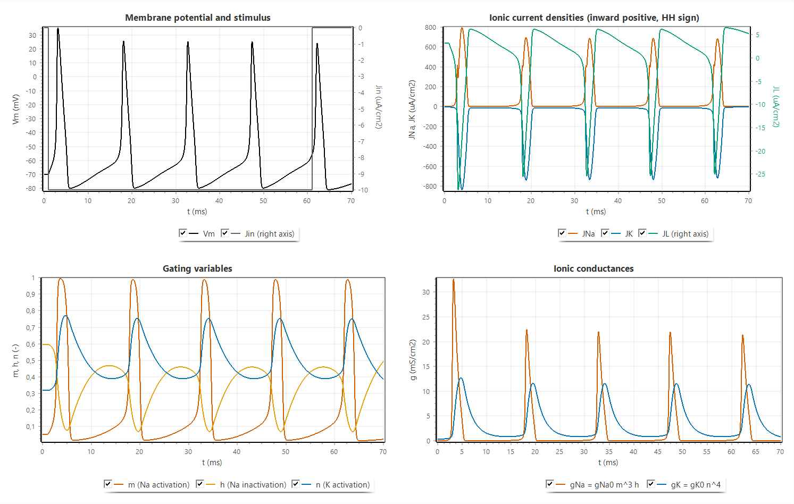
Figure 2.3. Tab 1 for a step of $J_{in}=-10$ µA/cm²: membrane voltage and stimulus, ionic currents (HH sign, inward positive), gating variables and conductances
The response to different constant levels is summarized in Table 2.2, obtained from 100 ms runs with the step starting at 1 ms. Levels of $-2$ µA/cm² or weaker remain subthreshold, $-3$ to $-5$ µA/cm² give a single action potential followed by a stable depolarized state, and repetitive firing starts between $-6$ and $-7$ µA/cm². Stronger inputs shorten the interval and raise the first peak slightly, until at $-100$ µA/cm² only one spike occurs and the membrane remains depolarized (depolarization block). The lecturer’s staircase protocol produces action potentials at 3.23, 28.36 and 40.01 ms, one at the onset of each new level: the $-5$ µA/cm² level only elicits a single onset spike (Table 2.2), and the $-10$ and $-20$ µA/cm² levels last only 13 and 12 ms, which is not longer than the interval needed for a second spike at these levels. Selecting the lecturer’s sequential RK4 changes the spike times by at most 0.01 ms (for example an interval of 17.15 ms instead of 17.14 ms at $-7$ µA/cm²), so the output of the program agrees with the lecturer’s method within the resolution of the plots, and the senior’s program, which uses the same equations with a small constant added to the rate denominators, shows qualitatively the same waveforms.
Table 2.2. Response of the space-clamped membrane to constant input levels (coupled RK4, $Δt=0.01$ ms, step from 1 ms, 100 ms run)
$J_{in}$ (µA/cm²) | Action potentials | Last ISI (ms) | First peak $V_{m}$ (mV)
$$-2$$ | 0 | - | -
$$-3$$ | 1 | - | 32.51
$$-5$$ | 1 | - | 34.05
$$-7$$ | 6 | 17.14 | 34.69
$$-10$$ | 7 | 14.64 | 35.26
$$-20$$ | 9 | 11.56 | 36.30
$$-40$$ | 11 | 9.21 | 37.49
$$-100$$ | 1, then block | - | 40.00

2.3.2 Gating Phase Plots
Figure 2.4 shows the trajectories of the three gates against $V_{m}$ for the same run, drawn over the steady-state curves. The trajectory of $m$ stays close to $m_{∞}\left(V_{m}\right)$ during the slow phases and separates from it only during the fast upstroke and downstroke, because $τ_{m}$ is shorter than 0.5 ms, the corresponding loop is narrow. The trajectories of $h$ and $n$ form wide loops that lie far from their steady-state curves, because $τ_{h}$ and $τ_{n}$ are several milliseconds: during the spike $h$ and $n$ cannot follow the voltage, and after it they recover only gradually. The first loop starts from the resting values ($h=0.60$, $n=0.32$) and is different from the following loops, which start from $h≈0.45$ because recovery between spikes is incomplete under the sustained current, this incomplete recovery is the refractoriness that limits the firing rate. Because the dots are plotted at a constant time step, their spacing shows the speed of the state: the dots are dense during the slow interspike depolarization and sparse on the upstroke, where $V_{m}$ changes by more than 100 mV within about a millisecond.
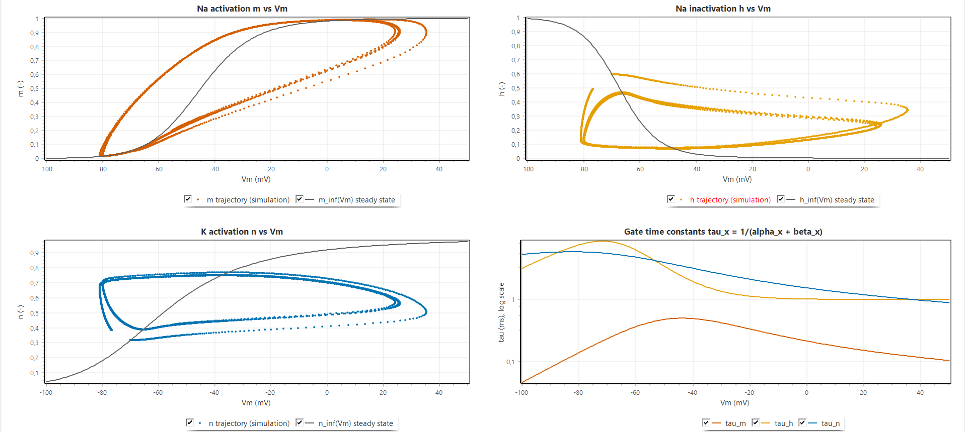
Figure 2.4. Tab 2: trajectories of $m$, $h$ and $n$ against $V_{m}$ (dots at a constant time step) over the steady states $x_{∞}\left(V_{m}\right)$, and the time constants $τ_{x}\left(V_{m}\right)$

2.3.3 Refractory Period
Figure 2.5 shows the refractory sweep with a conditioning pulse $J_{1}=-40$ µA/cm² of 0.5 ms and the test interval varied in steps of 0.5 ms, selected values are listed in Table 2.3. The rested single-pulse threshold is 13.27 µA/cm². For intervals up to 3.5 ms no test pulse up to 500 µA/cm² produces a second action potential, which is the absolute refractory period. At 4.5 ms the threshold is just below the search limit (496 µA/cm²), and it then falls steeply, to 85.8 µA/cm² at 7.5 ms and 37.3 µA/cm² at 10.5 ms, which is the relative refractory period. The threshold returns to within 5 % of the rested value at about 15 ms (13.75 µA/cm² at 15.5 ms). Between about 16.5 and 25 ms the threshold is even lower than at rest, with a minimum of 11.20 µA/cm² at 18.5 ms, about 16 % below the rested value. This supernormal phase is consistent with the gate dynamics, by then $n$ has decayed close to its resting value, while $h$, which recovered quickly during the after-hyperpolarization, is still slightly above its resting value, so that more sodium conductance is available than at rest. The right axis shows that a second action potential elicited late in the relative refractory period is smaller (30.3 mV at 10.5 ms against 36.3 mV at 17.5 ms), because the available sodium conductance is still reduced. The lower chart shows the corresponding paired-pulse responses for the interval chosen with the track bar.
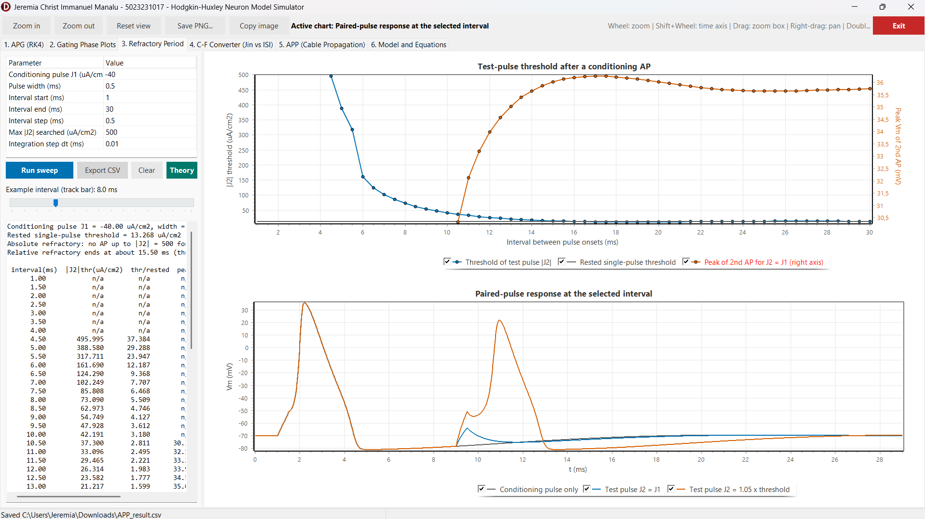
Figure 2.5. Tab 3: test-pulse threshold and peak of the second action potential against the interval between pulse onsets, and the paired-pulse response at the selected interval
Table 2.3. Test-pulse threshold after a conditioning action potential ($J_{1}=-40$ µA/cm², width 0.5 ms, rested threshold 13.27 µA/cm²)
Interval (ms) | Test threshold ${\left|J_{2}\right|}_{th}$ (µA/cm²) | Ratio to rested threshold
3.5 | none up to 500 | -
4.5 | 496.0 | 37.4
6.5 | 124.3 | 9.37
8.5 | 63.0 | 4.75
10.5 | 37.3 | 2.81
12.5 | 23.6 | 1.78
15.5 | 13.75 | 1.04
18.5 | 11.20 | 0.84
24.5 | 13.42 | 1.01
29.5 | 13.52 | 1.02

2.3.4 How the Jin Level Programs the Inter-Pulse Interval
Figure 2.6 and Table 2.4 show the steady firing obtained in tab 4 for constant levels from 0 to $-68$ µA/cm². Up to $-2$ µA/cm² the membrane is silent, from $-3$ to $-6$ µA/cm² it fires once or twice and then settles, and from $-7$ µA/cm² it fires tonically with an interval of 17.15 ms (58.3 Hz). The interval then decreases monotonically with $\left|J_{in}\right|$, steeply at first and more slowly at large inputs: 14.64 ms (68.3 Hz) at $-10$, 11.57 ms (86.5 Hz) at $-20$, 9.21 ms (108.6 Hz) at $-40$ and 8.33 ms (120.1 Hz) at $-54$ µA/cm². At $-55$ µA/cm² and beyond, firing stops after two or three spikes because the membrane stays depolarized and sodium inactivation does not recover (depolarization block). The input level therefore programs the inter-pulse interval within a range of roughly 8 to 17 ms. The saturation at large inputs reflects the refractory period of Section 2.3.3: however fast the membrane is recharged, a new spike cannot occur before $h$ and $n$ have partly recovered. The example traces in the lower chart illustrate the shorter intervals and the slightly smaller spike amplitude at strong inputs.
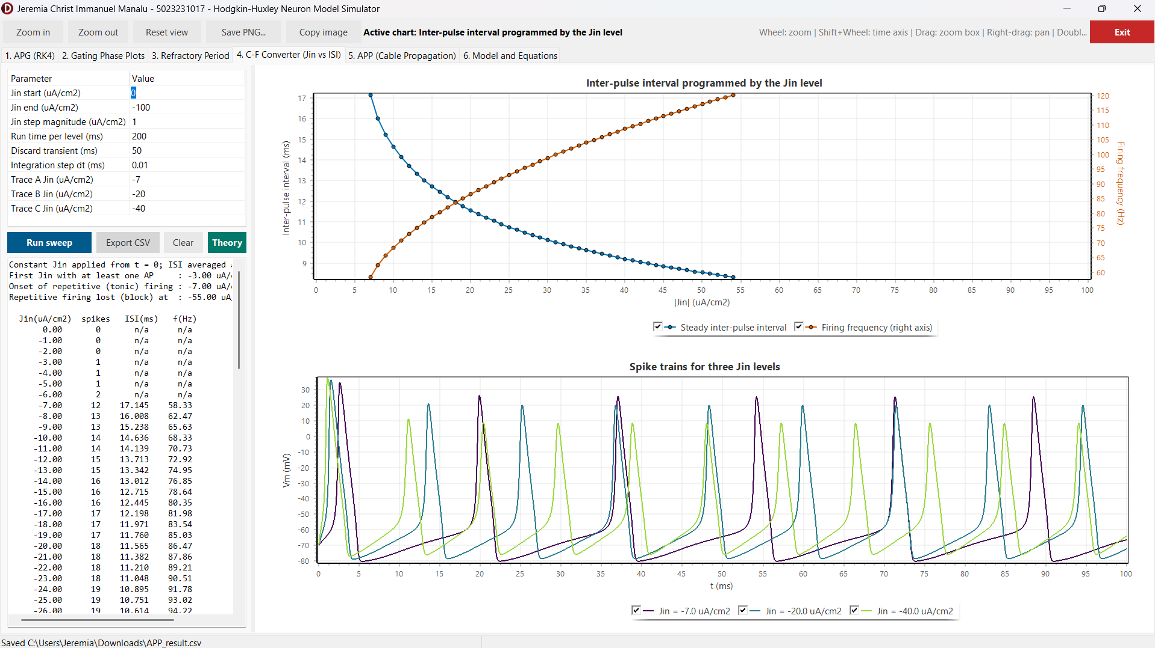
Figure 2.6. Tab 4: steady inter-pulse interval and firing frequency against $\left|J_{in}\right|$, and spike trains for three input levels
Table 2.4. Steady inter-pulse interval and firing frequency for selected input levels (program export)
$J_{in}$ (µA/cm²) | Mean ISI (ms) | Frequency (Hz)
$$-6$$ | - (2 spikes, no steady firing) | -
$$-7$$ | 17.15 | 58.3
$$-10$$ | 14.64 | 68.3
$$-15$$ | 12.72 | 78.6
$$-20$$ | 11.57 | 86.5
$$-30$$ | 10.13 | 98.7
$$-40$$ | 9.21 | 108.6
$$-54$$ | 8.33 | 120.1
$$-55$$ | depolarization block | -

2.3.5 Action Potential Propagation
Figure 2.7 shows tab 5 for the active squid-axon cable. The result memo confirms the cable constants derived in Section 2.2.3 ($r_{i}=19,893$ Ω/cm, $c_{m}=0.14954$ µF/cm, $D=0.33616$ cm²/ms, $r=0.3362$). The Vm(t) chart shows the same action potential arriving at successive recording sites with a constant delay, and the Vm(x) chart shows the wave as a pulse that moves along the axon with an unchanged shape. The 0 mV crossing times grow linearly with distance, from 0.652 ms at the stimulated end through 1.486 ms at 12 mm and 2.980 ms at 30 mm to 4.476 ms at 48 mm, which gives a conduction velocity of 12.04 m/s at 6.3 °C. The peak voltage is 33.03 mV along the whole middle part of the axon. It is slightly higher at the stimulated end (34.07 mV), where the stimulus adds to the membrane current, and at the sealed far end (37.32 mV), where no axial current can flow onward and the charge accumulates in the last segments. The spatial extent of the action potential, about 2 to 3 cm, is consistent with the product of the velocity and the spike duration.
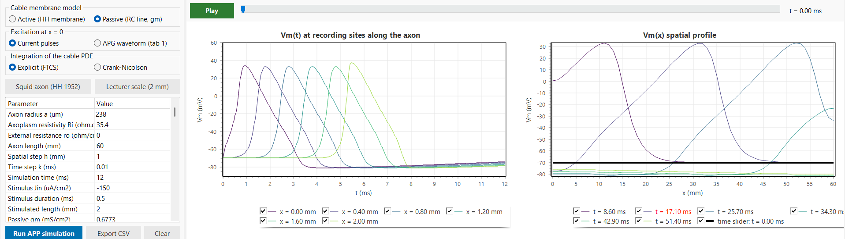
Figure 2.7. Tab 5, active cable with the squid-axon preset: parameters, Vm(t) at six recording sites and Vm(x) at six instants
Table 2.5 summarizes the parameter variations. Halving the spatial step to 0.5 mm (with a smaller time step to keep $r≤0.5$) changes the velocity by less than 2 %, which agrees with the second-order spatial accuracy of the scheme. Raising the temperature to 18.5 °C increases the velocity to 18.2 m/s, against 18.8 m/s calculated and 21.2 m/s measured by Hodgkin and Huxley [1], the agreement with their calculation is within about 3 %. In the passive mode no action potential appears: the depolarization decays from $-35.2$ mV at the stimulated end to $-68.1$ mV at 15 mm, in line with the computed length constant of 7.0 mm, which demonstrates that propagation requires the regenerative sodium current. A thin active fibre of 1 µm radius on a 2 mm axon propagates at about 0.78 m/s, consistent with $θ∝\sqrt{a}$. A step larger than $k_{max}$ is rejected by the program with the message predicted by Equation (2.21). Figure 2.8 shows the space-time behaviour in the 3D views, where the propagating action potential appears as a straight ridge in the $\left(x,t\right)$ plane whose slope is the inverse of the velocity, and Figure 2.9 shows the derivation window of the cable equation opened from the same tab.
Table 2.5. Propagation results for parameter variations
Case | Result
Active cable, squid axon, 6.3 °C, $h=1$ mm, $k=0.01$ ms | $θ=12.04$ m/s, peak 33.03 mV, $r=0.336$
Active cable, $h=0.5$ mm | $θ=12.25$ m/s
Active cable, 18.5 °C | $θ=18.2$ m/s (HH 1952: 18.8 calculated, 21.2 measured)
Passive cable, $g_{m}=0.6773$ mS/cm² | no AP, $-35.2$ mV at 0 mm to $-68.1$ mV at 15 mm, $λ=7.0$ mm
Thin active fibre, $a=1$ µm, 2 mm, $h=0.1$ mm | $θ≈0.78$ m/s, $r=0.14$
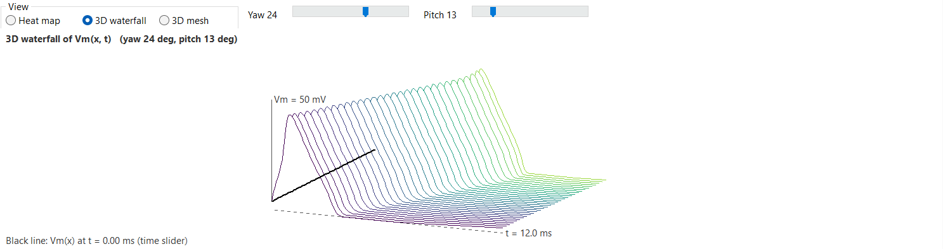
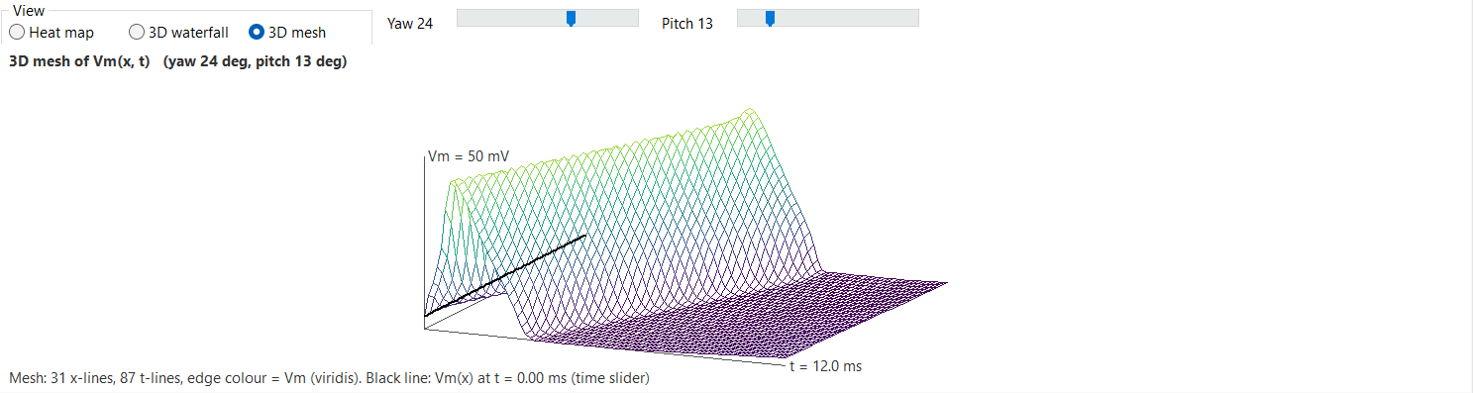
Figure 2.8. Space-time views of $V_{m}\left(x,t\right)$ for the active cable: (a) 3D waterfall, (b) 3D mesh, the bold line is the spatial profile at the time-slider position
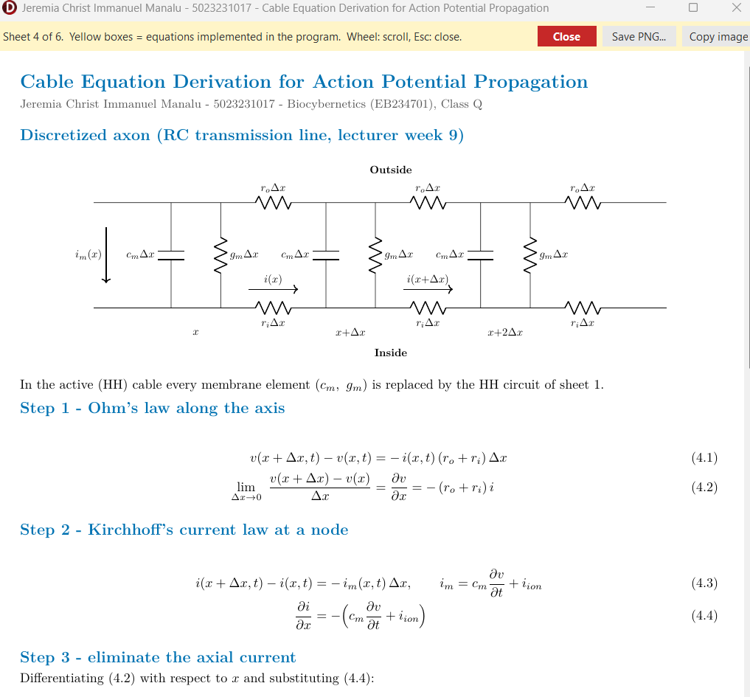

Figure 2.9. Derivation window of the cable equation (sheet 4) opened from the main form, the yellow boxes are the equations used by the cable solver
Compared with the reference programs, the results differ in two respects that are intended. The senior’s propagation program updates the voltage with a pure diffusion term and an arbitrarily chosen coefficient applied to a stored APG trace, without any membrane current, so its signal can only spread and decay, the active cable of this work regenerates the action potential at every node and therefore propagates without decrement, which is what Problem 3 asks the model to exhibit. The lecturer’s program, in contrast, solves the passive cable equation driven by the APG output, which the lecturer-scale preset reproduces (Figure 2.10), while the squid-axon preset was added because its velocity can be checked against the 1952 paper.
Figure 2.10 shows the lecturer-scale preset. The APG model, driven by $J_{in}=-10$ µA/cm² from 1 ms, fires at 2.91, 17.84, 32.49 and 47.12 ms, and these four action potentials are imposed at $x=0$. Along the passive cable each of them appears as a separate wave that becomes smaller and broader with distance: the peaks at 0, 0.4, 0.8, 1.2, 1.6 and 2.0 mm are 35.3, $-9.5$, $-32.7$, $-45.0$, $-50.4$ and $-51.9$ mV, with a passive length constant of 1.02 mm. The repeated ridges in the 3D views are therefore successive action potentials in time on one axon, not several axons, which is the same picture as in the lecturer’s and the senior’s plots. The Crank-Nicolson scheme gives the same peaks within 0.1 mV at this grid ($r=0.044$). Its advantage appears at larger diffusion numbers: for the squid axon with $h=0.5$ mm and $k=0.01$ ms ($r=1.345$) the explicit scheme is refused, whereas the Crank-Nicolson scheme runs and gives 12.12 m/s, within 1 % of the explicit result with a four times smaller step (12.25 m/s). With the active membrane and the same APG drive on a 0.1 mm grid ($r=0.71$, Crank-Nicolson), every wave is regenerated and travels at 1.95 m/s. A train of three current pulses 15 ms apart likewise produces three propagating action potentials at 12.04 m/s on the squid axon.
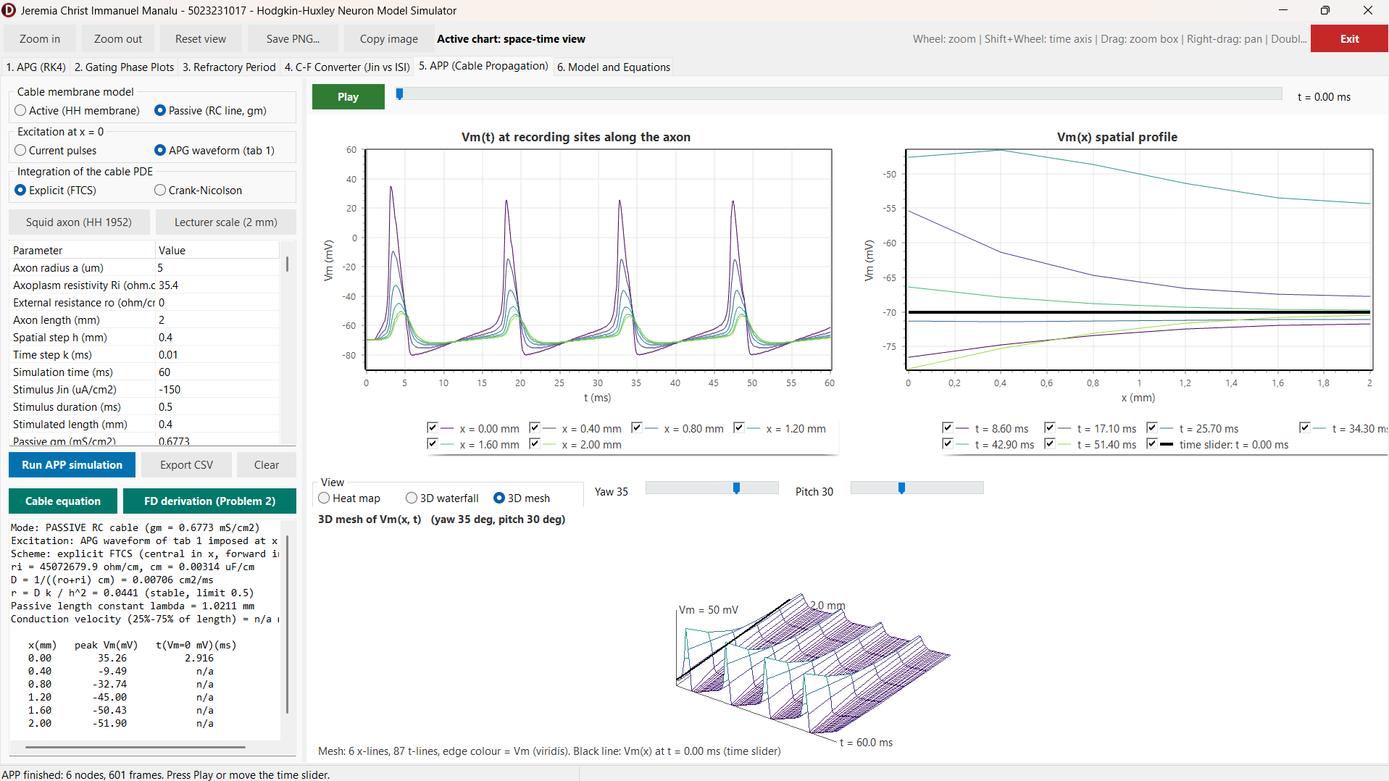
Figure 2.10. Tab 5, lecturer-scale preset: passive 2 mm cable driven at $x=0$ by the APG waveform of tab 1 ($J_{in}=-10$ µA/cm²), Vm(t) at 0 to 2.0 mm and the space-time view of the four attenuated waves.

2.4 Evaluation and Discussion
The results agree with the theoretical baseline of Chapter I in every aspect examined. The voltage equation (1.2) with the currents (1.3) and the kinetics (1.5) to (1.9) reproduces the resting equilibrium exactly and generates action potentials of the expected amplitude and duration once the output is aligned with Equation (2.2). The phase plots make the separation of time scales of Figure 1.2 directly visible: the fast gate $m$ tracks its steady state, while the slow gates $h$ and $n$ lag behind and recover only gradually, and this lag is the common cause of the two behaviours of Problem 1. It produces the absolute refractory period of about 4 ms and the relative refractory period ending near 15 ms, and it bounds the inter-pulse interval from below, so that the input level can program the interval only between about 17 and 8 ms before depolarization block sets in. The supernormal phase found after the relative refractory period is not an artefact of the threshold search, which is monotone and resolved to 0.008 µA/cm², but a property of the HH kinetics that follows from the different recovery rates of $h$ and $n$.
For propagation, the derivation of Problem 2 and the program of Problem 3 are consistent, where the cable constants and the stability number printed by the program equal the hand-calculated values, the velocity converges with second-order behaviour when $h$ is halved, and the comparison of the active and passive modes isolates the regenerative sodium current as the reason why an action potential propagates without decrement while a passive signal decays within a few length constants. The velocity of 18.2 m/s at 18.5 °C is within about 3 % of the value calculated by Hodgkin and Huxley [1], the remaining difference to their measurement of 21.2 m/s is of the same size as the difference between their own calculation and measurement, and it is expected because only the rate constants are temperature-scaled and the axon is modelled as a uniform cylinder.
Several limitations must be kept in mind. The explicit FTCS scheme is only first-order accurate in time and is stable only for $r≤1/2$, so fine spatial grids require small time steps, the Crank-Nicolson option removes this restriction for the diffusion term, while the membrane term remains explicit. The sealed-end boundary raises the peak at the far end, and spikes are defined by a 0 mV crossing, so graded responses below 0 mV are not counted. Three discrepancies in the lecture material were identified and handled explicitly: the time step printed as “10 sec” (10 µs), the term $0.1\left(v+2.5\right)$ printed in $α_{m}$ instead of $0.1\left(v+25\right)$, and the node index of the leakage term in the transcribed propagation code. In addition, the final line of the slide lacks the brackets around the second difference. In each case the program follows the derivation and the original paper, and offers the lecturer’s integration method for direct comparison.

CHAPTER III. CONCLUSION
A Hodgkin-Huxley neuron simulator was developed in Delphi 13 with a numerical core that is independent of the user interface. The action potential is generated by integrating the four HH equations with the classical RK4 method and, for comparison, with the lecturer’s sequential RK4 at a step of 0.01 ms, and the output is aligned to the membrane voltage with $V_{m}=-\left(v+70\right)$ mV, which turns the downward spikes of the 1952 sign convention into physiological action potentials from $-70$ mV to about $+35$ mV. A paired-pulse threshold search shows an absolute refractory period of about 4 ms and a relative refractory period ending near 15 ms, and a constant input programs the inter-pulse interval from about 17 ms (58 Hz) at $-7$ µA/cm² to about 8 ms (120 Hz) at $-54$ µA/cm², beyond which depolarization block occurs.
The integration of the cable equation was derived with a central difference in space and a forward difference in time, giving the explicit update $v_{j}^{n+1}=v_{j}^{n}+r\left(v_{j+1}^{n}-2v_{j}^{n}+v_{j-1}^{n}\right)+k\left(J_{in}-J_{ion}\right)/C_{m}$ with $r=k/\left[\left(r_{o}+r_{i}\right)c_{m}h^{2}\right]$ and the stability condition $r≤1/2$, which for the passive membrane is the final expression of the lecture slide, and a Crank-Nicolson variant removes the stability limit. Implemented with an HH membrane at every node, the scheme shows a regenerating action potential that travels at constant amplitude and at 12.0 m/s for the squid axon at 6.3 °C (18.2 m/s at 18.5 °C, close to the 18.8 m/s calculated by Hodgkin and Huxley), whereas the passive cable driven by the APG waveform, as in the lecturer’s program, carries each action potential as a wave that decays within about 1 mm. Propagation is therefore exhibited by the combination of axial current flow and the regenerative sodium current.
The two reviewed papers show the reach of the Hodgkin-Huxley formalism: extended with more than a dozen conductances, it explains the bursting of the respiratory pacemaker, and approximated with base-2 functions, it runs in real time on small FPGAs for neuromorphic and neuroprosthetic applications. All equations used by the program, including the derivation of Problem 2, are available in the program as separate sheets and are highlighted in this report.

REFERENCES
[1] A. L. Hodgkin and A. F. Huxley, “A quantitative description of membrane current and its application to conduction and excitation in nerve,” J. Physiol., vol. 117, no. 4, pp. 500-544, Aug. 1952, doi: 10.1113/jphysiol.1952.sp004764.
[2] A. Arifin, “Hodgkin-Huxley neuron model,” lecture notes, Biocybernetics (EB234701), Dept. Biomed. Eng., Inst. Teknologi Sepuluh Nopember, Surabaya, Indonesia, 2026.
[3] A. Arifin, “Hodgkin-Huxley neuron model simulation,” lecture slides and source code, Biocybernetics (EB234701), Dept. Biomed. Eng., Inst. Teknologi Sepuluh Nopember, Surabaya, Indonesia, 2026.
[4] S. C. Chapra and R. P. Canale, Numerical Methods for Engineers, 7th ed. New York, NY, USA: McGraw-Hill Education, 2015.
[5] J. Malmivuo and R. Plonsey, Bioelectromagnetism: Principles and Applications of Bioelectric and Biomagnetic Fields. New York, NY, USA: Oxford Univ. Press, 1995.
[6] K. W. Morton and D. F. Mayers, Numerical Solution of Partial Differential Equations: An Introduction, 2nd ed. Cambridge, U.K.: Cambridge Univ. Press, 2005.
[7] B. Amini, A. Bidani, J. B. Zwischenberger, and J. W. Clark, Jr., “A model of the pacemaking neuron of the respiratory central pattern generator,” IEEE Trans. Neural Syst. Rehabil. Eng., vol. 13, no. 2, pp. 120-124, Jun. 2005, doi: 10.1109/TNSRE.2005.847379.
[8] S. Haghiri, A. Naderi, B. Ghanbari, and A. Ahmadi, “High speed and low digital resources implementation of Hodgkin-Huxley neuronal model using base-2 functions,” IEEE Trans. Circuits Syst. I, Reg. Papers, vol. 68, no. 1, pp. 275-287, Jan. 2021, doi: 10.1109/TCSI.2020.3026076.
[9] D. Noble, “A modification of the Hodgkin-Huxley equations applicable to Purkinje fibre action and pace-maker potentials,” J. Physiol., vol. 160, no. 2, pp. 317-352, Feb. 1962, doi: 10.1113/jphysiol.1962.sp006849.
[10] S. Buccelli et al., “A neuromorphic prosthesis to restore communication in neuronal networks,” iScience, vol. 19, pp. 402-414, Sep. 2019, doi: 10.1016/j.isci.2019.07.046.
[11] T. Levi, P. Bonifazi, P. Massobrio, and M. Chiappalone, “Editorial: Closed-loop systems for next-generation neuroprostheses,” Front. Neurosci., vol. 12, Art. no. 26, Feb. 2018, doi: 10.3389/fnins.2018.00026.

